|  |
| --- |
|  |
| **Tāhūrangi Getting Started Guide:**  Te Marautanga o Aotearoa |





# Table of **Contents**

Table of Contents 2

Whakapapa ​ 3

Introduction 3

Getting started 4

Homepage for Te Marautanga o Aotearoa 5

Searching for resources on Tāhūrangi 6

Extending your search on Tāhūrangi 7

Te Marautanga o Aotearoa Resource Tiles 8

Functionality of an Te Marautanga o Aotearoa Resource 10

Signing into Tāhūrangi 12

Setting a personal profile 13

Kete 14

Collections 15

Sharing Collections 15

Glossary of terms 16

# Whakapapa ​

In October 2022, the Ministry was gifted the platform’s official name and whakapapa by Dr Wayne Ngata: Tāhūrangi.

Tāhū, often referred to as Tāhuhu, is the central ridgepole that runs the length of a wharenui. This pole is important within any whare: it not only holds it up, but depicts the whakapapa of those who descend from it. Its use within the name is also a reflection of Te Tāhuhu o te Mātauranga, acknowledging that the new curriculum platform is a taonga the Ministry of Education is responsible for. ​

Rangi, as in Ipurangi or internet, is used here to describe knowledge that sits within the sky (often referred to as information in ‘the cloud’). Rangi also refers to Ranginui – the atua who takes care of everything across the sky.

Many of the kupu Māori found throughout this site, are connected to the whakapapa and whakaaro of our gifted kupu ‘*Tāhūrangi’*. To support your understanding of the terms used on this site, there is a glossary [kupu taka] that can be found at the end of this *‘Getting Started Guide’* .

## 

# Introduction

Welcome to Tāhūrangi, our new digital home for teaching and learning resources from early learning through to secondary schooling across the national curriculum of Aotearoa New Zealand. This guide will introduce you to some of its different parts, so that you can start making the most of your time here. You might find a lot of features feel familiar already – this guide will help you figure out the rest.

# Getting started

On the Tāhūrangi home page, you will see a welcome message with three curriculum tiles: Te Whāriki Online, Te Marautanga o Aotearoa, or New Zealand Curriculum Online. You can navigate to your curriculum of choice by clicking on those curriculum tiles, or by clicking on the buttons of the same name at the top and bottom tool bar.

You can toggle the Language Button to switch between English and te reo Māori. This feature is also available within Te Marautanga o Aotearoa resources.

The homepage also has a news section, where you can read the latest curriculum news from Te Tāhuhu o te Mātauranga | Ministry of Education.

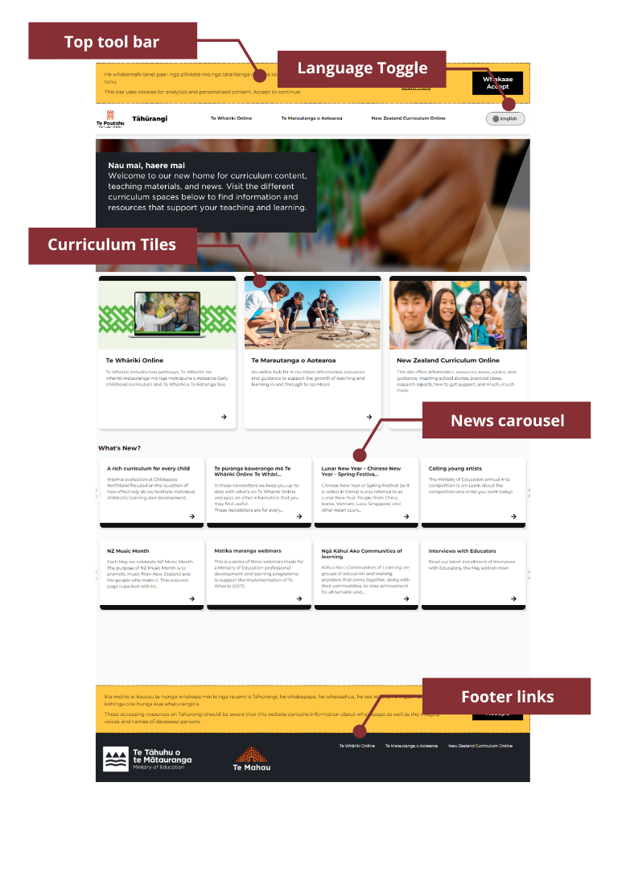

# 

# Homepage for Te Marautanga o Aotearoa

Once you click on a curriculum tile or tool bar button, you will land on the homepage for that part of the national curriculum.

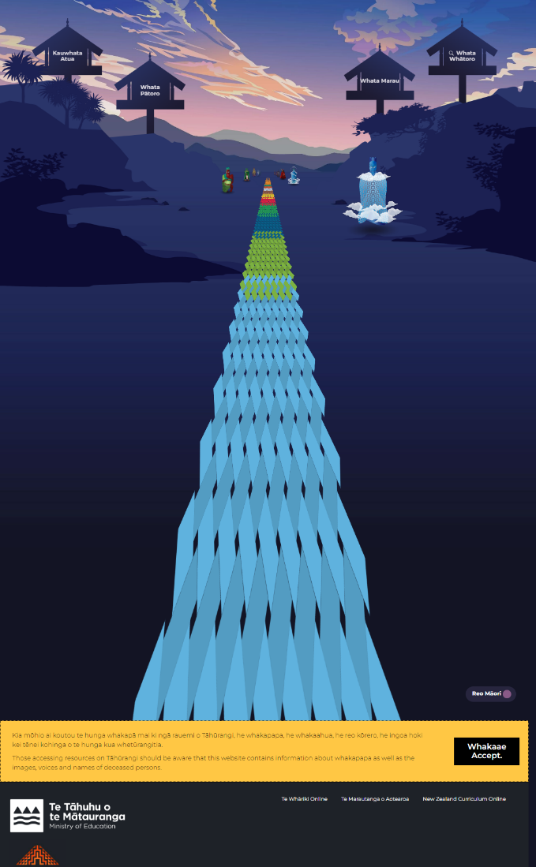

This isthe homepage of *Te Marautanga o Aotearoa*, a part of Tāhūrangi*.* From here,you can start exploring all the resources, information, and news related to *Te Marautanga o Aotearoa*.

Across *Te Marautanga o Aotearoa*, you can find the Support button at the top of every resource and every kaupapa landing page. This is where you can find Getting Started Guides for each curriculum area.

# 

# Searching for resources on Tāhūrangi

For some of the kaupapa in the Whata Pātoro clicking the links may automatically redirect you to Kauwhata Reo.

You can get a sense of what resources to search for by exploring inside the whata and clicking on the links:

1. Whata Marau for Te Marautanga o Aotearoa document, materials related to the redesign - Te Tīrewa Marautanga, resources for NCEA achievement standards derived from TMoA and tools to support curriculum
2. Whata Pātoro – resources developed by kaupapa
3. Whata Atua – resources grouped by atua

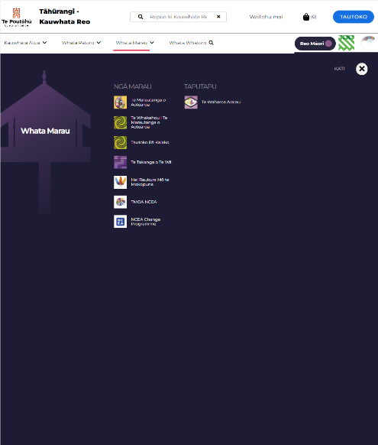

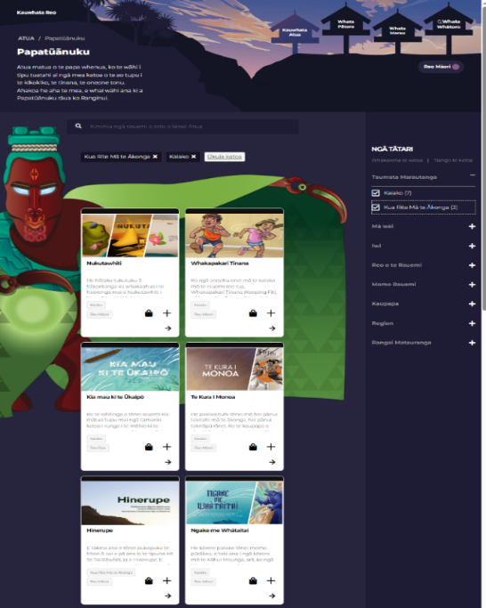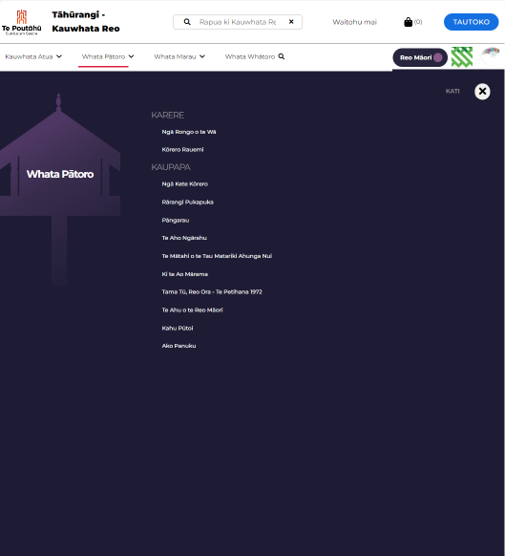

If you know what you are looking for, use the search bar in the Whata Whātoro to do a site wide search. The filters will help you narrow down the results.

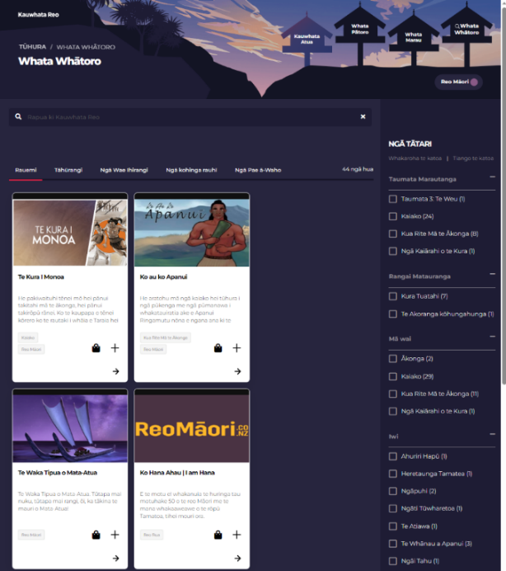

# 

# Extending your search on Tāhūrangi

Following your search (if you press enter and obtain all search returns), you will be presented with a search results page. This has been designed to maximise the use of filters (located on either the left-hand or right-hand side of the search results) to quickly and easily show you all the available resources you are searching for.

Using the search filters will start to narrow down the search returns (resources) to ensure your key area(s) of focus are surfaced.

Tāhūrangi also enables users to quicky and easily access all the resources for your search across the other curricula; all you need to do is select the Tāhūrangi tab on the search results screen and you will see how many resources are available in the other curricula. To access these, all you need to do is click the curriculum where you want to see the available resources and you will be directed to those search returns (on a new tab).

The search screen also enables you to access any artefacts (support materials) that match your search return, or to access external sites (e.g., National Libraries) by selecting those tabs.

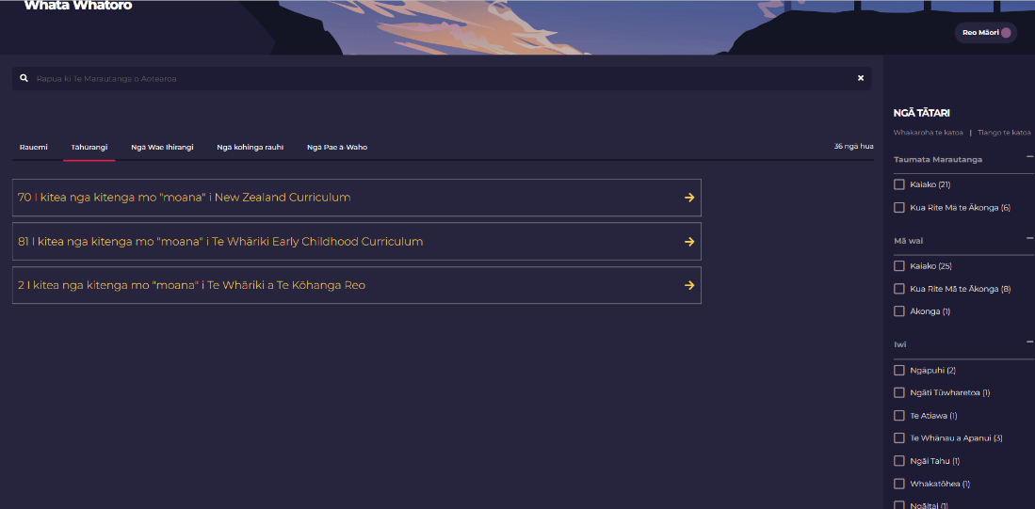

# Te Marautanga o Aotearoa Resource Tiles

You’ll find resource tiles, like the ones pictured below, in your search results, in Atua pages and when you navigate to a page using the navigation bar.

These tiles show the following:

**Image:** A thumbnail (small picture) representing the resource

**Title:** The name of the resource

**Description:** A brief explanation of what the resource is about

**Tags:** Two tags appear on the tile. The top tag is the audience (who the resource is intended for).

The bottom tag is what language the resource is provided in.

**Kete:** The kete, represented by the basket icon, lets you add a resource directly to your kete. You can view your kete at any time and download the resources you have added to it at a time that suits you. This is very similar to adding an item to your cart on any online shopping site. See “Kete” section of this guide for more details.

**Plus symbol:** The plus symbol lets you to add something directly to one of your personalised collections, so that you can come back to it quickly anytime. This feature is currently only available to those with an Education Sector Logon. See “Collections” section of this guide for more details.

**Arrow:** Clicking the arrow will open the resource.

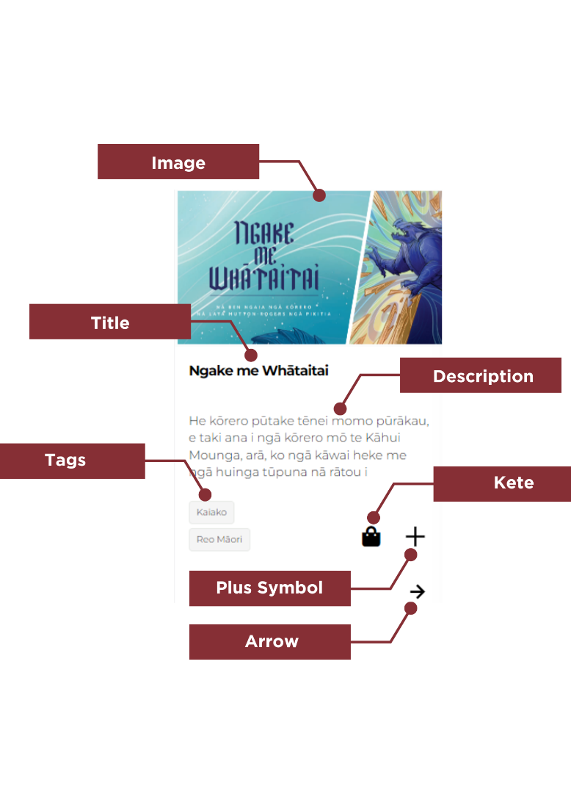

# Te Marautanga o Aotearoa Resource Tiles - Landing Pages

Resource tiles, like below, display on Te Marautanga o Aotearoa landing pages, such as that for Te Aho Ngārahu.

These tiles show the following:

**Image:** A thumbnail image representing the resource

**Title:** The resource title

**Description Field:** The name of the iwi/hapū/whānau from where the pūrākau is based.

**Arrow:** Clicking the arrow will open the resource.

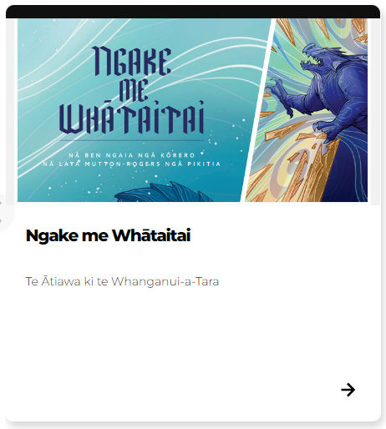

# 

# Functionality of a Te Marautanga o Aotearoa Resource

Te Marautanga o Aotearoa resources on Tāhūrangi have a number of different features.

At the top of the page, you will find a header. In this header section (as pictured below), you **will find:**

* the **Search Bar**
* the **Sign In** button
* your **kete**
* **Support**
* the **Navigation Bar**
* Language **Toggle**
* **Links** to other curricula

In general, for teaching and learning resources, the teaching resource will be displayed first followed by teacher support material. The teaching resource will appear in different ways such as a book cover that can be located in your kura or ordered through Down the Back of the Chair, an app, video or linking you to an external site. Some teaching resources do not have teacher support material.

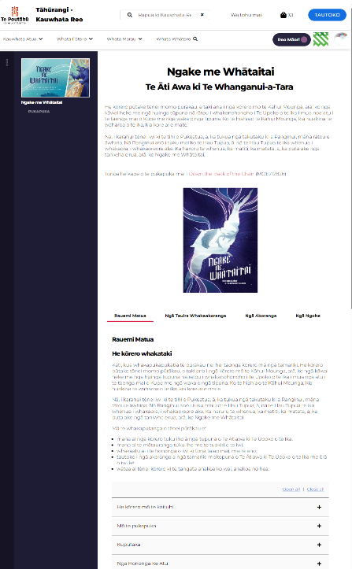

**Search Bar:** This is easily identifiable by the spyglass icon. We have intentionally chosen to privilege Te Reo Māori here, regardless of which language you have the language toggle set to, with the text in the search bar reading **“Rapua ki Kauwhata Reo.”**

Using this search bar will return results from across Kauwhata Reo. See “Search” for more details.

**Sign In:** Educators with a registered ESL login can click here to sign into their Tāhūrangi profile.

Kete: This is where resources you have added to your kete can be found and downloaded. See “kete” for more details.

**Support Button**: The support button will take you to our Tāhūrangi support page. This page has key information such as the whakapapa of Tāhūrangi, how-to videos, and details on how to contact us.

**Navigation Bar:** You can find things on Tāhūrangi either by search or using the navigation bar. The navigation bar has drop downs for each of the whata on Kauwhata Reo.

**Language Toggle:** The language toggle allows the user to “toggle” between Te Reo Māori and English. The toggle will change the instructional language on the page. With the toggle switched to Reo Māori the About this resource box would give the instruction “Tāpirihia ki te kete,” with it set to English it will appear as “Add to resource.” This toggle will not translate every resource, however, where a resource has an English alternative, when the toggle is switched to English, the English will be presented.

**Links to other curricula areas:** The two icons for NZC and Te Whāriki link to the two curricula sites on Tāhūrangi respectively.

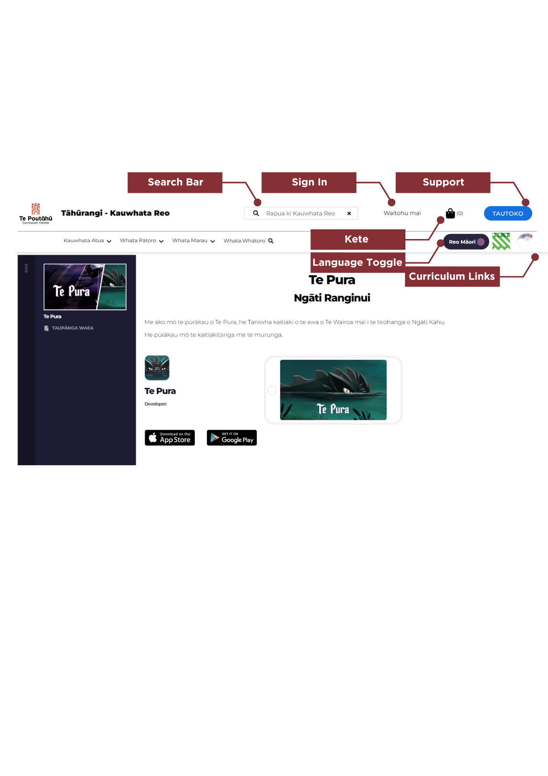

**Mō te** **rauemi/About this resource box**: The About this resource box contains key details about the resource such as the wahanga ako and taumata it supports, and where relevant, which kaupapa it aligns to.

In this box you will also find these buttons: **Add to Kete, Add to Collection, Download resource**

Where a resource has supporting materials available such as a book, a PDF download, or an audio file, these are downloadable in the About this resource box under the “**Materials that come with this resource**” heading.

**Kaupapa Tile**: Many of the taonga housed on Te Marautanga o Aotearoa site may belong to a particular kaupapa or series of resources. These taonga will have a tile at the bottom of the page, identifying the kaupapa, and when clicked, will to take you to a page with other connected resources.

# 

# Signing into Tāhūrangi

While content, resources and many of the features and functions of Tāhūrangi are available to all users, as educators with an Education Service Logon (ESL) logon, you have access to a few extra features.

Once you sign into Tāhūrangi using your Education Service Logon (ESL) you can: ​

* Create a personal profile,
* Curate collections of your favourite resources so you always have these at your fingertips,
* Share your collections with other educators that have previously signed into Tāhūrangi, and have others share their collections with you, ​
* Create a personal profile,
* Subscribe to receiving communications through the Tāhūrangi communications channel, and
* View your download history (downloads from your Kete).

There are two different areas across Tāhūrangi where you can sign in using your Education Service Logon (ESL):

1. The sign-in option on the header bar
2. When you are downloading resources from your kete, you will be prompted to logon.

Option 1: Sign in on the header bar (circled in red).

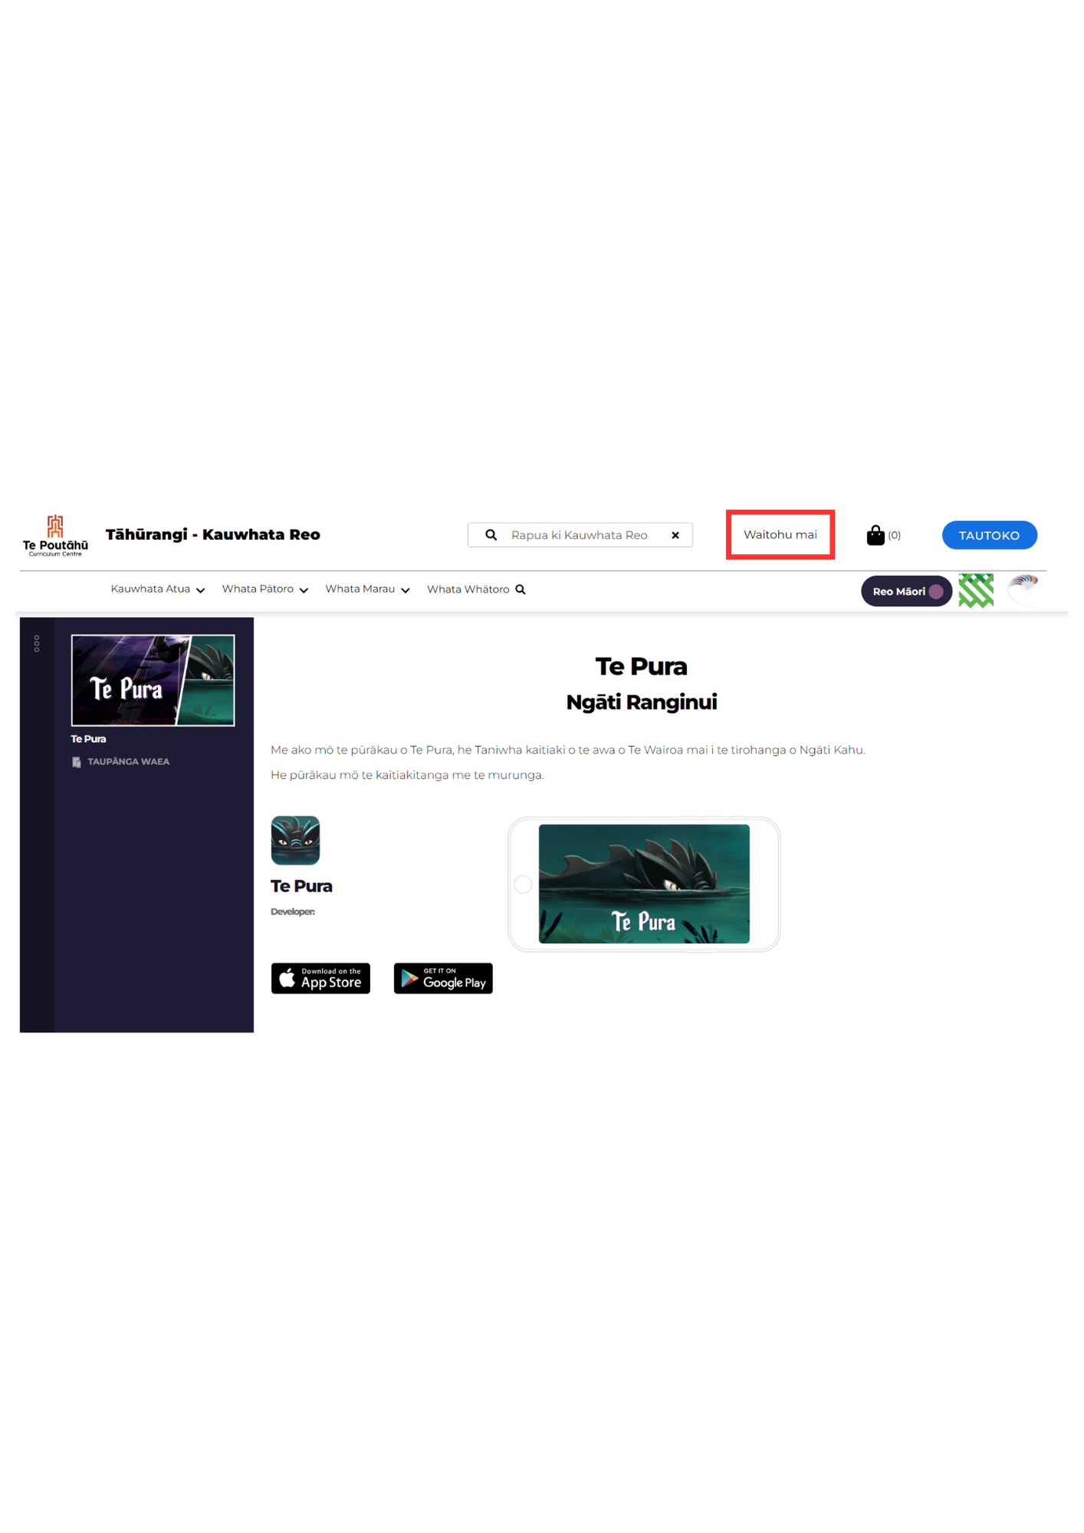

Option 2: Download from your kete.

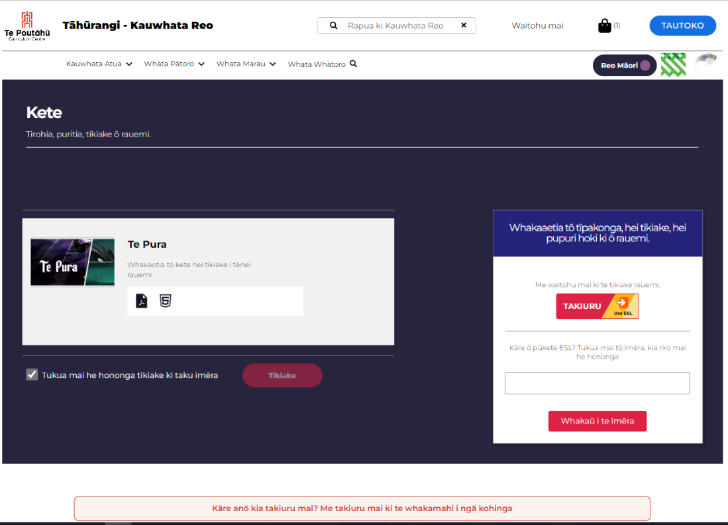

If you don’t have an Education Service Logon (ESL), please contact us at [service.desk@education.govt.nz](mailto:service.desk@education.govt.nz) to find out how to get one.

Once you have signed in, you will be automatically signed out after 20 mins if you are not active. If you are active, you will have 60 minutes before you are signed out. This is to make sure we can keep your details secure.

# Setting a personal profile

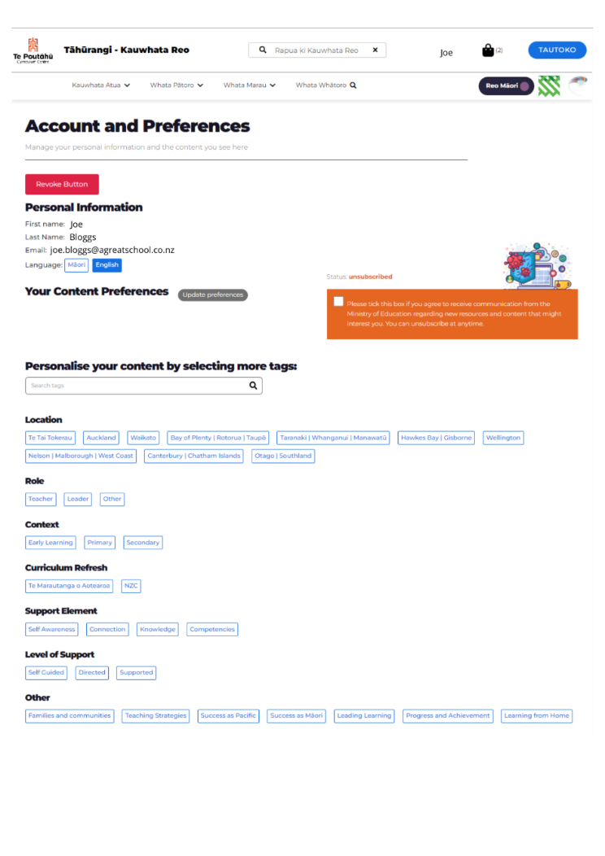

When you sign in, you can create a personal profile by selecting as few, or as many, descriptors about you and what you are interested in. Alternatively, you can choose your own tags from the search bar.

Once Tāhūrangi is fully functional, the system will remember your preferences and will personalise your experience. If you agree to receive communications from us, then we can make sure the communications reflect the curriculum areas, language(s), or age levels you select.

Your personal information will be kept secure. If you want to know more about this, please read the privacy statement in the page footer or contact us at [tahurangi@education.govt.nz](mailto:tahurangi@education.govt.nz).

# 

# Kete

The kete on Tāhūrangi can be likened to a shopping cart; it allows you to add any number of items, which you can then go back to review or download within the same browser session.

To download the items in the kete, click the kete icon in the top navigation bar.

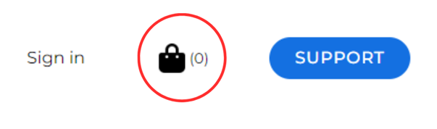

A pop-up menu will appear on the right-hand side of the screen. At the bottom of this menu, click “Finalise Kete.”

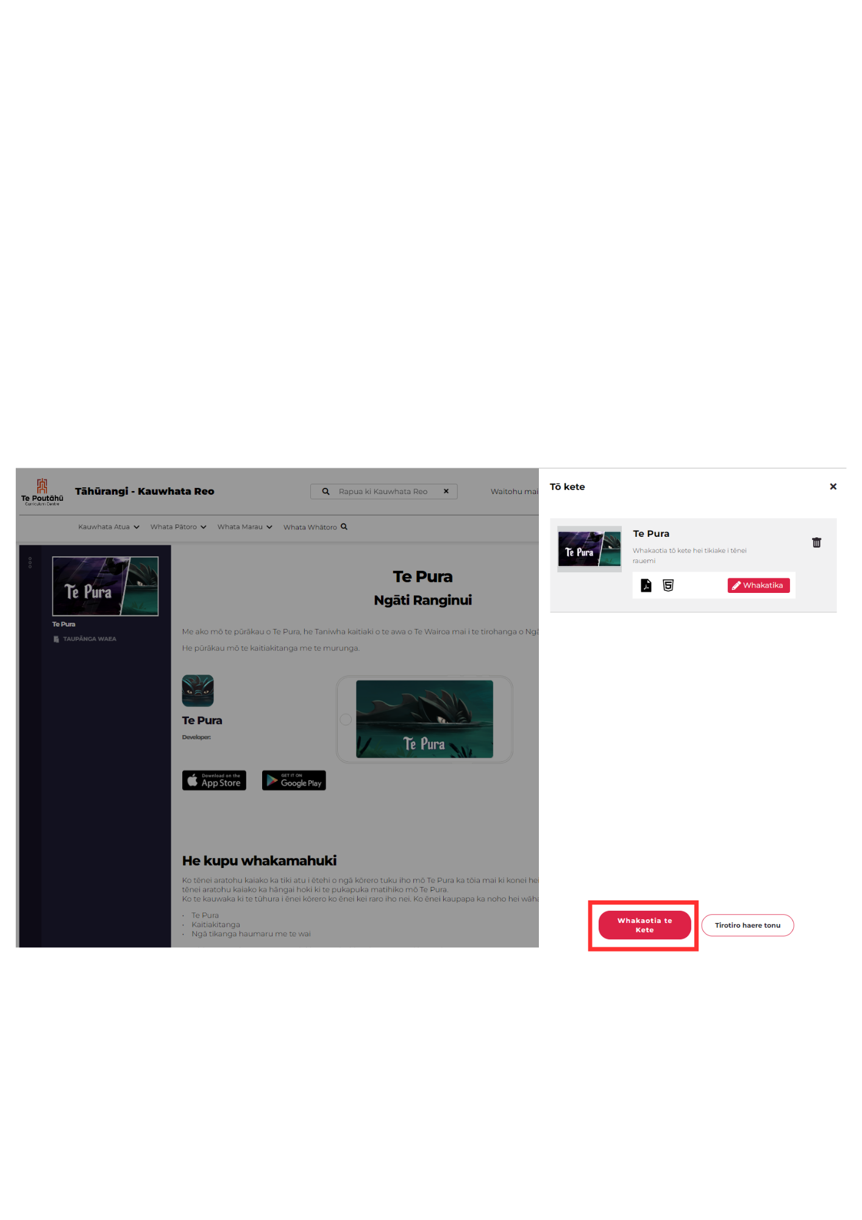

From here, you can either click “Download” to download the resources to your device immediately, or click the check box and enter your email address to have a link to your kete emailed to your inbox. This link will re-open your kete to enable the resources added to be downloaded. This link is valid for 72 hours.

By clicking on the kete icon on a resource page, you can add downloadable resources to your kete to download at a time that suits you. This is ideal if you’re not currently connected to wifi. However, at the moment, some resources that you have added to your kete may be unavailable. We are working hard to correct this issue and we anticipate all resources will be available soon.

# 

# Collections

The collections feature on Tāhūrangi is currently only available to those with a registered ESL login. When you are signed-in to your ESL profile on Tāhūrangi, you can create a collection, and add any number of resources to it. Resources can be added to a single collection regardless of which curriculum site they belong to.

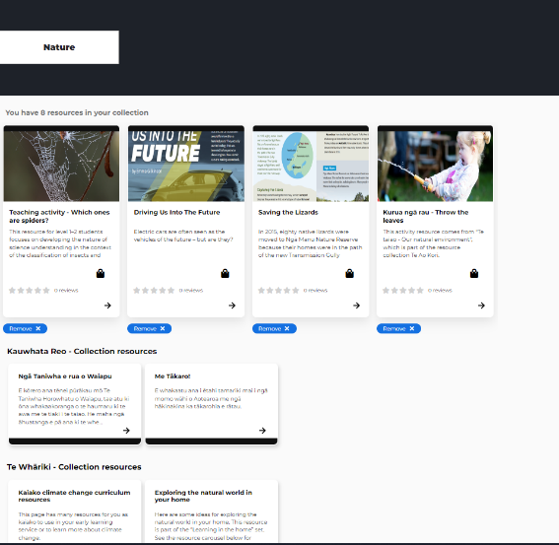 

If you are viewing your collection on the site for Te Marautanga o Aotearoa, you will have direct access to the resources on Te Marautanga o Aotearoa. To access resources on either New Zealand Curriculum Online or Te Whāriki within that collection you will be redirected to the below screen.

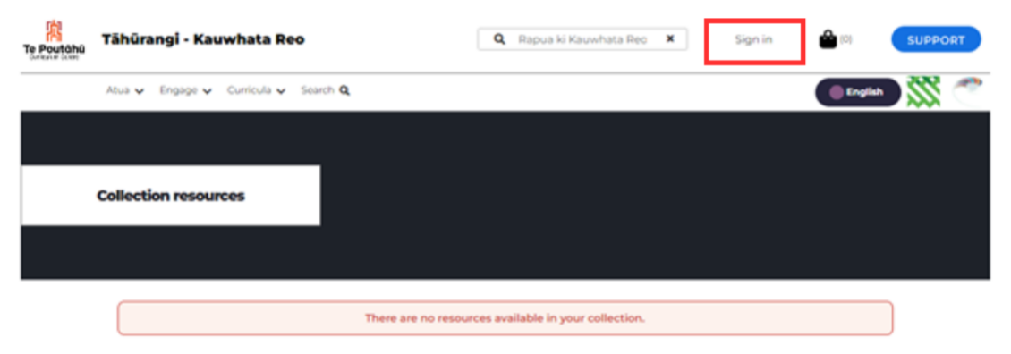

Click sign in, and the collection will be displayed.

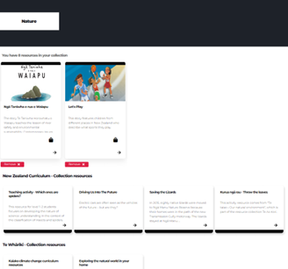

When a user is logged in, the “sign in” (**Waitohu mai**, if page toggled to te reo Māori) button in the top header will change to their preferred name (as per their ESL profile). To find saved collections, a user needs to sign into their profile and then click their name in the header. All saved collections will appear here.

# Sharing Collections

From the saved collections, collections can also be shared with others. To share, click the check box at the top of a collection, and then the Share Collections button.

You will then be prompted to add the email address of the ESL registered user you would like to share with.

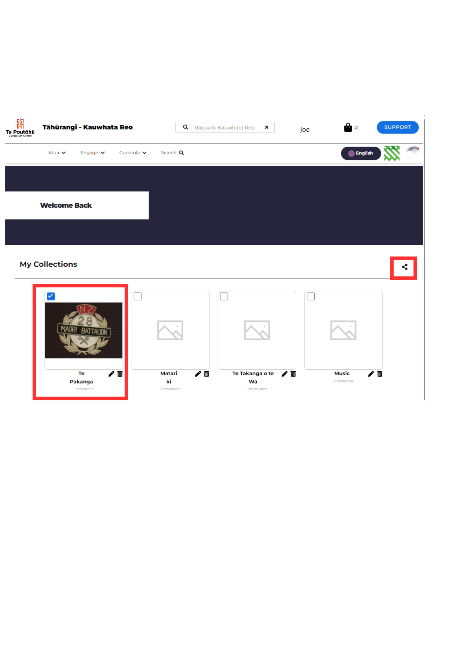

# 

# Glossary of terms

* **Arrow:** Clicking the arrow will open the resource.
* **Breadcrumb:** The breadcrumb shows you where in the site the resource that you have open is so that you can navigate back to the broader area it sits within.
* **Collections:** The collections feature on Tāhūrangi is currently only available to those with a registered ESL login. When a user is signed-in to their ESL profile on Tāhūrangi, they can create a collection, and add any number of resources to it. Resources can be added to the collection from any curriculum; however, **resources in a collection can only be accessed via the collection when a user is in the curriculum site the resource belongs to**.
* **Description:** A brief explanation of what the resource is about
* **ESL Login:** An Education Sector Login
* **Image:** A thumbnail (small picture) representing the resource
* **Kete:** The kete symbol allows the user to add something directly to the kete for download from the search results page. This is where resources you have added to your kete can be found and downloaded. **Kete** is a te reo Māori term for a woven basket.
* **Links to other curricula areas:** Icons for each curriculum area are available on the top toolbar.
* **Navigation Bar:** You can find resources on Tāhūrangi either by using the search function or using the navigation bar on each site. The navigation bar has drop-downs. Resources for specific learning areas can be found under the heading “Learning Content and Resources.”
* **Plus symbol:** The plus symbol allows the user to add something directly to their personalised collection from the search results page. This feature is currently available to those with an ESL login.
* **Rapua**: “Rapua” is the te reo Māori term *to search*.
* **Search Bar:** This is easily identifiable by the spyglass icon. We have intentionally chosen to use te reo Māori here, with the text in the search bar reading **“Rapua ki Te Marautanga o Aotearoa.” “**Rapua” means *to search*. Using this search bar will return results from across Te Marautanga o Aotearoa site.
* **Sign In:** Educators with a registered ESL login can click here to sign into their Tāhūrangi profile.
* **Support Button**: The support button will take you to our Tāhūrangi support page. This page has key information such as the whakapapa of Tāhūrangi, Getting Started Guides, and details on how to contact us.
* **Tags:** Two tags appear on a resource tile. The top tag is the audience (who the resource is intended for). The bottom tag is the resource language.
* **Title:** The name of the resource

**Kupu Taka**

|  |  |
| --- | --- |
| Kāre e taea te tuari kohinga piako | Empty collection cannot be shared |
| kohinga tārewa | Pending collections |
| Ngā Wae Ihirangi | Artifacts/Materials that support a resource/Downloadable content |
| Ngā kohinga rauhī | Curated collections |
| Ngā Pae ā-Waho | External Sites |
| Tauwhaituhi ā-kiriata | Video transcript |
| Tauwhaituhi ā-oro | Audio transcript |
| Whakaotia tō kete | Finalise your kete |
| Whakaotia tō kete hei tikiake i tēnei rauemi | Finalise your kete to download this resource |
| Whakarērea tēnei kohinga | Reject collection |