|  |
| --- |
|  |
| Tāhūrangi  Getting Started Guide:  New Zealand Curriculum Online |





# Table of **Contents**

Table of Contents 2

Whakapapa ​ 3

Introduction 3

Getting started 4

Homepage for New Zealand Curriculum Online 5

Searching for resources on Tāhūrangi 6

Extending your search on Tāhūrangi 7

NZC Resource Tiles 8

Functionality of an NZC Resource 9

Functionality of an NZC Resource (continued) 10

Signing into Tāhūrangi 11

Setting a personal profile 12

Kete 13

Collections 14

Sharing Collections 14

Glossary of terms 15

# Whakapapa ​

In October 2022, the Ministry was gifted the platform’s official name and whakapapa by Dr Wayne Ngata: Tāhūrangi.

Tāhū, often referred to as Tāhuhu, is the central ridgepole that runs the length of a wharenui. This pole is important within any whare: it not only holds it up, but depicts the whakapapa of those who descend from it. Its use within the name is also a reflection of Te Tāhuhu o te Mātauranga, acknowledging that the new curriculum platform is a taonga the Ministry of Education is responsible for. ​

Rangi, as in Ipurangi or internet, is used here to describe knowledge that sits within the sky (often referred to as information in ‘the cloud’). Rangi also refers to Ranginui – the atua who takes care of everything across the sky.

# Introduction

Welcome to Tāhūrangi, our new digital home for teaching and learning resources from early learning through to secondary schooling across the national curriculum of Aotearoa New Zealand. This guide will introduce you to some of its different parts, so that you can start making the most of your time here. You might find a lot of features feel familiar already – this guide will help you figure out the rest.

# Getting started

On the Tāhūrangi home page, you will see a welcome message with three curriculum tiles: Te Whāriki Online, *Te Marautanga o Aotearoa*, or New Zealand Curriculum Online. You can navigate to your curriculum of choice by clicking on those curriculum tiles, or by clicking on the buttons of the same name at the top and bottom tool bar.

You can toggle the Language Button to switch between English and te reo Māori.

The homepage also has a news section, where you can read the latest curriculum news from Te Tāhuhu o te Mātauranga | Ministry of Education.

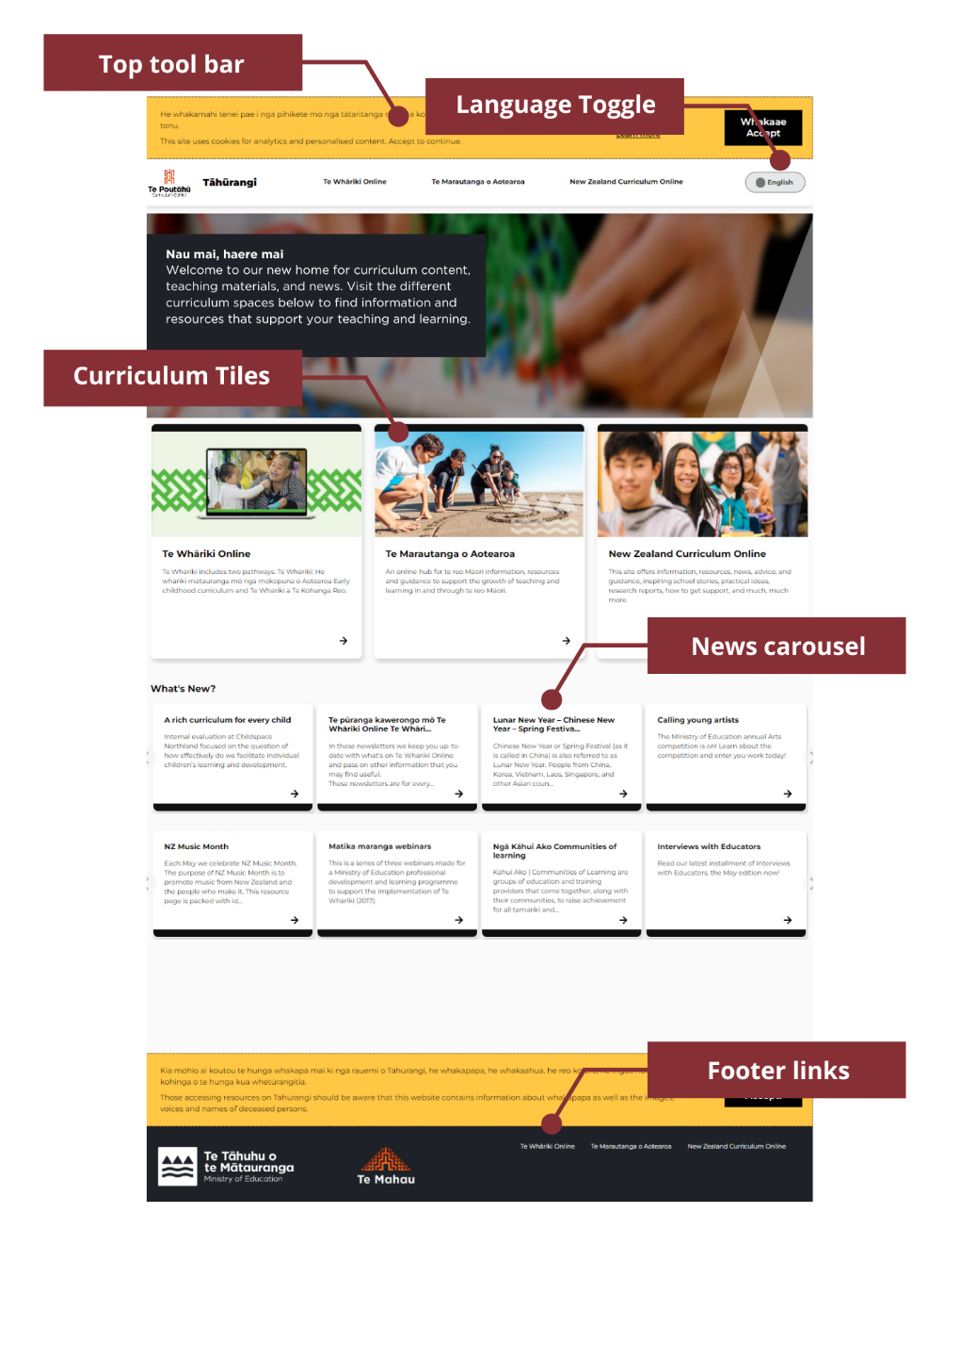

# 

# Homepage for New Zealand Curriculum Online

Once you click on a curriculum tile or tool bar button, you will land on the homepage for that part of the national curriculum.

This isthe homepage of *The New Zealand Curriculum Online*, a part of Tāhūrangi*.* From here,you can start exploring all the resources, information, and news related to *The New Zealand Curriculum*.

Each page on this part of Tāhūrangi has a blue Support button in the top right corner. This is where you can find Getting Started Guides for each curriculum area.

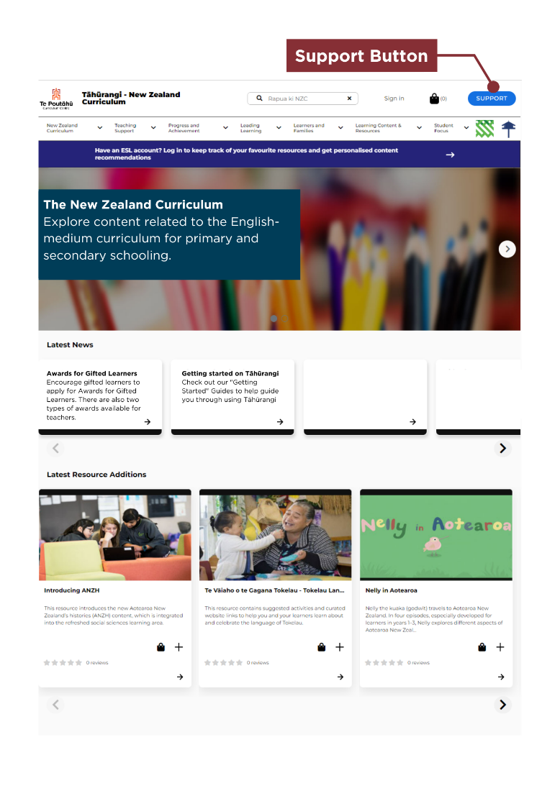

# 

# Searching for resources on Tāhūrangi

You can start your search for resources related to *The New Zealand Curriculum* by:

* using the search bar at the very top of the homepage
* using the navigation bar to explore the different areas (or landing pages) related to *The New Zealand Curriculum*
* using the second search bar in the body of any landing page.

Search bars are easily identifiable by their spyglass icon and by the words “rapua ki.” **“**Rapua” means *to search* in te reo Māori.

You can also refine the results you get by selecting one or more of the filters on the side of the search results page.

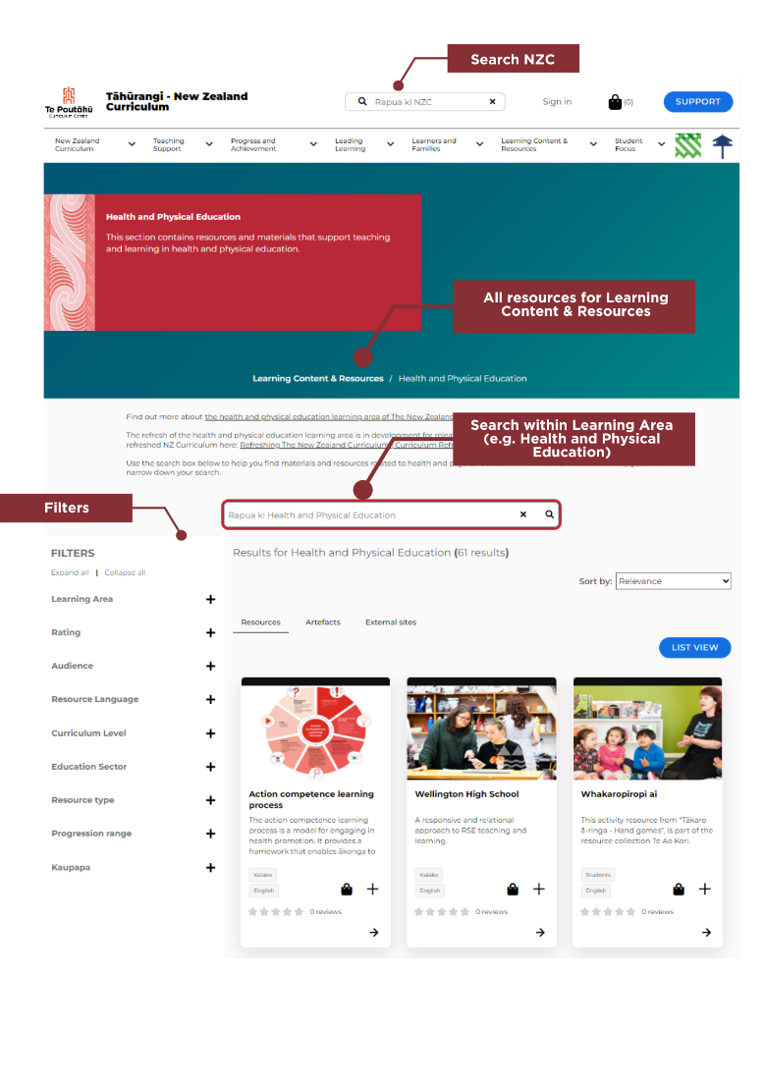

# 

# Extending your search on Tāhūrangi

Following your search (if you press enter and obtain all search returns), you will be presented with a search results page. This has been designed to maximise the use of filters (located on either the left-hand or right-hand side of the search results) to quickly and easily show you all the available resources you are searching for.

Using the search filters will start to narrow down the search returns (resources) to ensure your key area(s) of focus are surfaced.

Tāhūrangi also enables users to quicky and easily access all the resources for your search across the other curricula; all you need to do is select the Tāhūrangi tab on the search results screen and you will see how many resources are available in the other curricula. To access these, all you need to do is click the curriculum where you want to see the available resources and you will be directed to those search returns (on a new tab).

The search screen also enables you to access any artefacts (support materials) that match your search return, or to access external sites (e.g., National Libraries) by selecting those tabs.

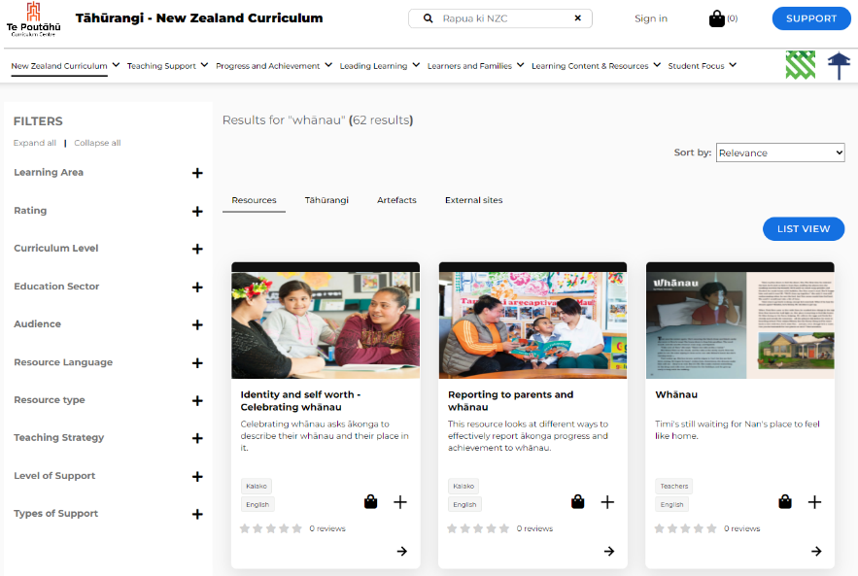

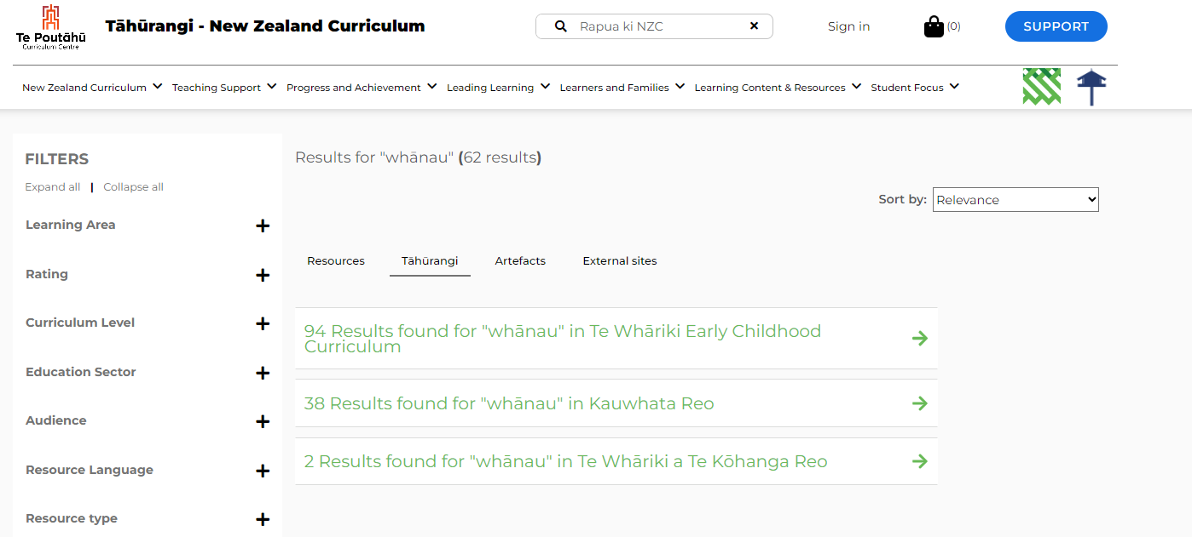

# 

# NZC Resource Tiles

You’ll find resource tiles, like the ones pictured below, in your search results and when you navigate to a page using the navigation bar.

These tiles show the following:

* **Image:** A thumbnail (small picture) representing the resource
* **Title:** The name of the resource
* **Description:** A brief explanation of what the resource is about
* **Tags:** Two tags appear on the tile. The top tag is the audience (who the resource is intended for). The bottom tag is what language the resource is provided in.
* **Kete:** The kete, represented by the basket icon, lets you add a resource directly to your kete. You can view your kete at any time, and download the resources you’ve added to it at a time that suits you. This is very similar to adding an item to your cart on any online shopping site. See “Kete” section of this guide for more details.
* **Plus symbol:** The plus symbol lets you to add something directly to one of your personalised collections, so that you can come back to it quickly anytime. This feature is currently only available to those with an Education Sector Logon. See “Collections” section of this guide for more details.
* **Arrow:** Clicking the arrow will open the resource.

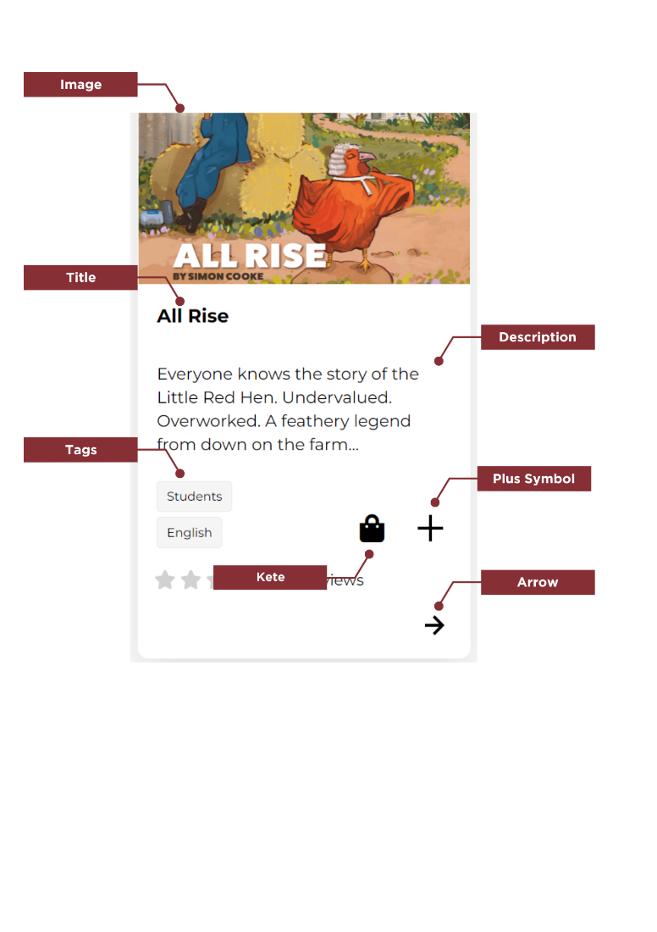

# 

# Functionality of an NZC Resource

New Zealand Curriculum resources on Tāhūrangi have a number of different features.

At the top of the page, you will find a header. In this header section (as pictured below), you will find:

* your **kete**
* **Support**
* the **Navigation Bar**
* **Links** to other curricula
* **Breadcrumb**

**Kete**: This is where resources you have added to your kete can be found and downloaded. See “Kete” section of this guide for more details.

**Support Button**: The support button will take you to our Tāhūrangi support page. This page has key information such as the whakapapa of Tāhūrangi, Getting Started Guides, and details on how to contact us.

**Navigation Bar:** You can find resources on the NZC site either by search or using the navigation bar. The navigation bar has drop-downs. Resources for specific learning areas can be found under the heading “Learning Content and Resources.”

**Links to other curricula areas:** The two icons, for Te Whāriki and Te Marautanga o Aotearoa, link to the two curricula sites on Tāhūrangi, respectively.

**Breadcrumb:** The breadcrumb shows you where in the site the resource that you have open is so that you can navigate back to the broader area it sits within.

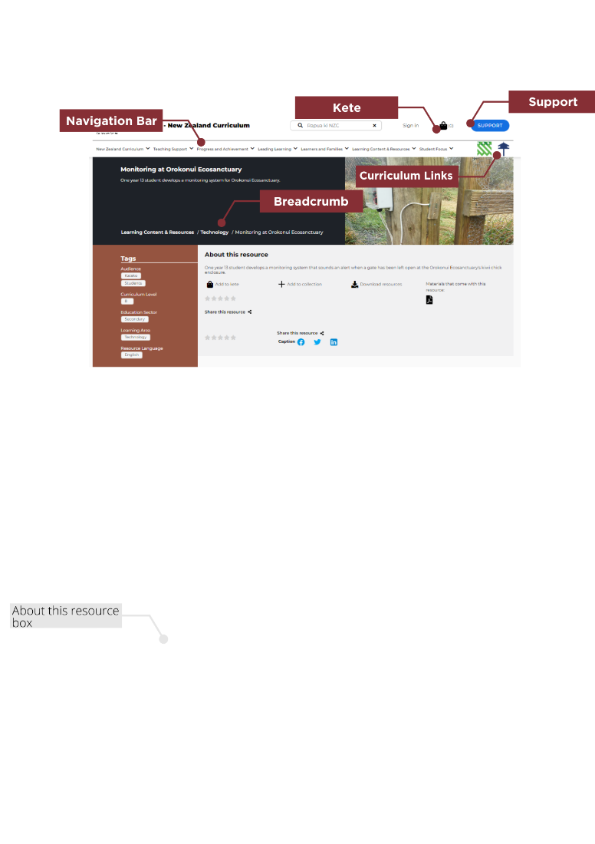

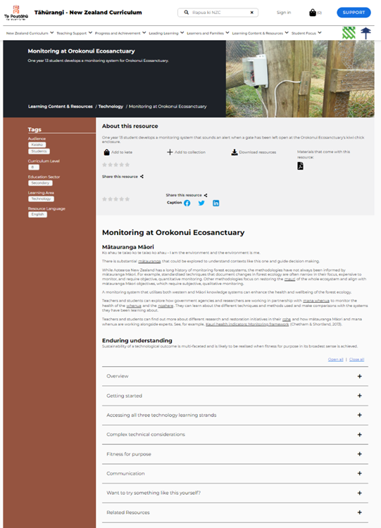

# 

# Signing into Tāhūrangi

While content, resources and many of the features and functions of Tāhūrangi are available to all users, as educators with an Education Service Logon (ESL) logon, you have access to a few extra features.

Once you sign into Tāhūrangi using your Education Service Logon (ESL) you can: ​

* Create a personal profile,
* Curate collections of your favourite resources so you always have these at your fingertips,
* Share your collections with other educators that have previously signed into Tāhūrangi, and have others share their collections with you, ​
* Create a personal profile,
* Subscribe to receiving communications through the Tāhūrangi communications channel, and
* View your download history (downloads from your Kete).

There are two different areas across Tāhūrangi where you can sign in using your Education Service Logon (ESL):

1. The sign-in option on the header bar
2. When you are downloading resources from your kete, you will be prompted to logon.

Option 1: Sign in on the header bar (circled in red).

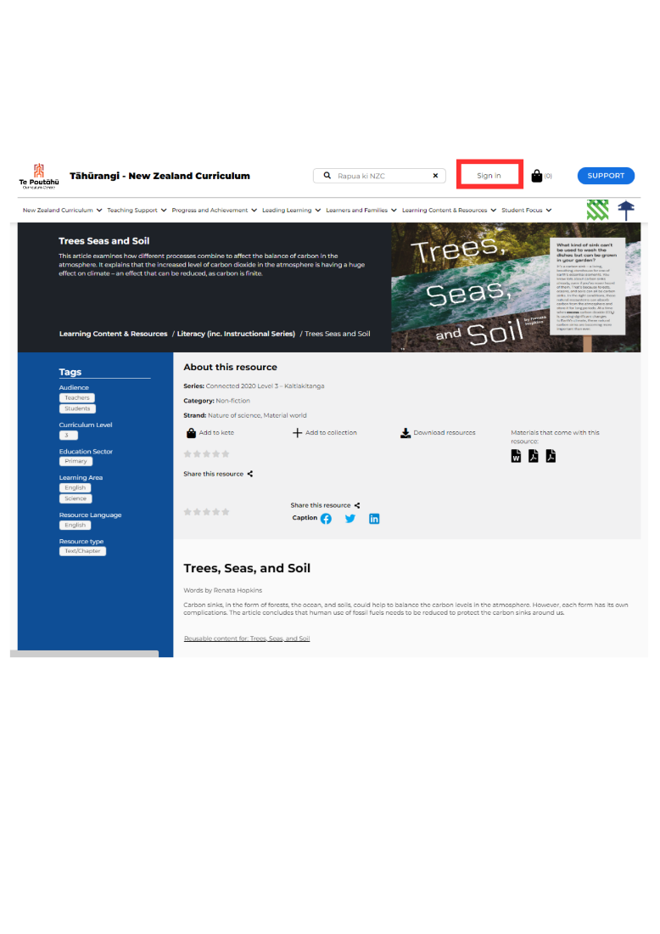

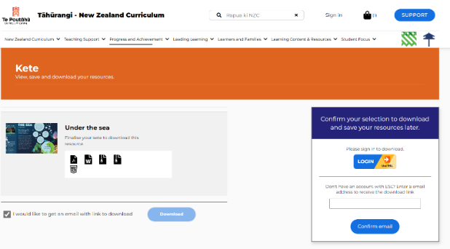

Option 2: Download from your kete.

If you don’t have an Education Service Logon (ESL), please contact us at [service.desk@education.govt.nz](mailto:service.desk@education.govt.nz) to find out how to get one.

Once you have signed in, you will be automatically signed out after 20 mins if you are not active. If you are active, you will have 60 minutes before you are signed out. This is to make sure we can keep your details secure.

# Setting a personal profile

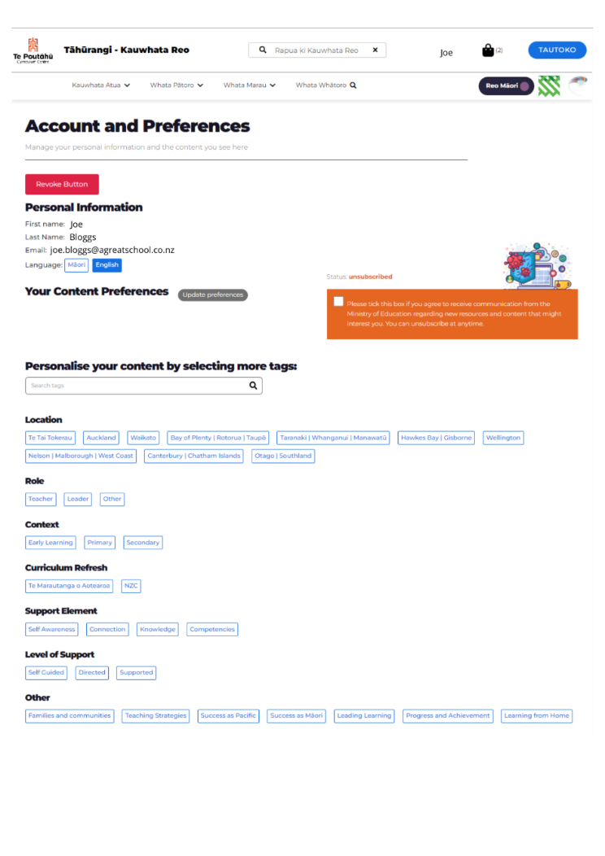

When you sign in, you can create a personal profile by selecting as few, or as many, descriptors about you and what you are interested in. Alternatively, you can choose your own tags from the search bar.

Once Tāhūrangi is fully functional, the system will remember your preferences and will personalise your experience. If you agree to receive communications from us, then we can make sure the communications reflect the curriculum areas, language(s), or age levels you select.

Your personal information will be kept secure. If you want to know more about this, please read the privacy statement in the page footer or contact us at [tahurangi@education.govt.nz](mailto:tahurangi@education.govt.nz).

# 

# Kete

The kete on Tāhūrangi can be likened to a shopping cart; it allows you to add any number of items, which you can then go back to review or download within the same browser session.

To download the items in the kete, click the kete icon in the top navigation bar.

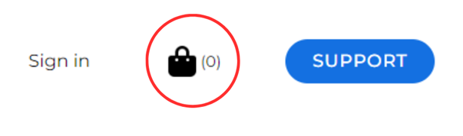

A pop-up menu will appear on the right-hand side of the screen. At the bottom of this menu, click “Finalise Kete.”

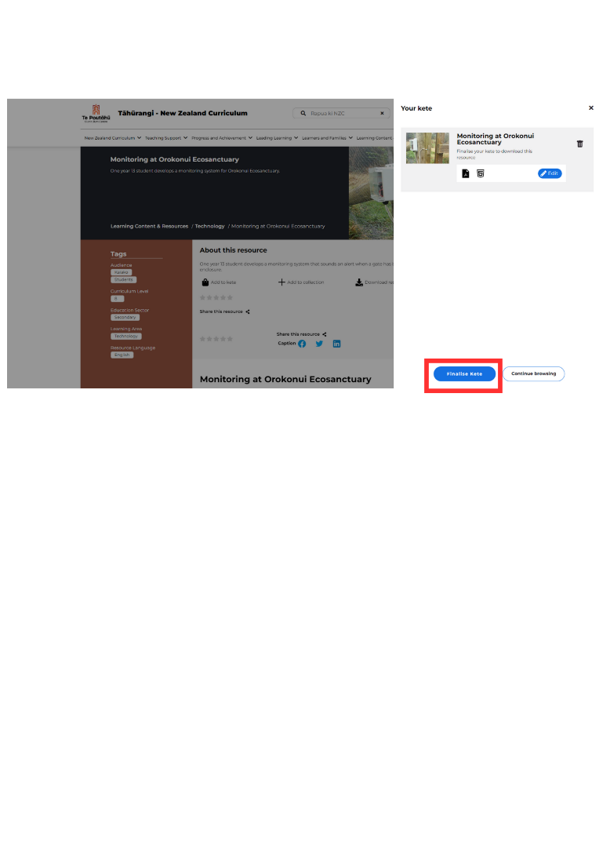

From here, you can either click “Download” to download the resources to your device immediately, or click the check box and enter your email address to have a link to your kete emailed to your inbox. This link will re-open your kete to enable the resources added to be downloaded. This link is valid for 72 hours.

By clicking on the kete icon on a resource page, you can add downloadable resources to your kete to download at a time that suits you. This is ideal if you’re not currently connected to wifi. However, at the moment, some resources that you have added to your kete may be unavailable. We are working hard to correct this issue and we anticipate all resources will be available soon.

# 

# Collections

The collections feature on Tāhūrangi is currently only available to those with a registered ESL login. When you are signed-in to your ESL profile on Tāhūrangi, you can create a collection, and add any number of resources to it.

We are still working on the ’collections’ function that enables logged-in users to save the resources they’d like to go back to easily in one place. Users can create a collection of resources from anywhere on Tāhūrangi, but they can only view and download resources from the curriculum area that the resource belongs to.

We are working on getting this fixed, but it may take a while. So, for now, you may need to add extra steps into your process for viewing all of your saved resources. To view a collection that you have created in *Te Whāriki Online*, *Te Marautanga or Aotearoa*, or *New Zealand Curriculum Online*, you must return to that curriculum area via its homepage.

When a user is logged in, the “sign in” (**Waitohu mai**, if page toggled to te reo Māori) button in the top header will change to their preferred name (as per their ESL profile). To find saved collections, a user needs to sign into their profile and then click their name in the header. All saved collections will appear here.

# Sharing Collections

From the saved collections, collections can also be shared with others. To share, click the check box at the top of a collection, and then the Share Collections button.

You will then be prompted to add the email address of the ESL registered user you would like to share with.

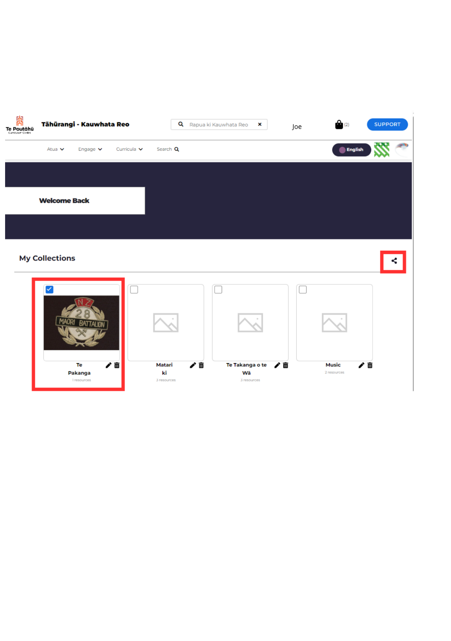

# Glossary of terms

* **Arrow:** Clicking the arrow will open the resource.
* **Breadcrumb:** The breadcrumb shows you where in the site the resource that you have open is so that you can navigate back to the broader area it sits within.
* **Collections:** The collections feature on Tāhūrangi is currently only available to those with a registered ESL login. When a user is signed-in to their ESL profile on Tāhūrangi, they can create a collection, and add any number of resources to it. Resources can be added to the collection from any curriculum; however, **resources in a collection can only be accessed via the collection when a user is in the curriculum site the resource belongs to**.
* **Description:** A brief explanation of what the resource is about
* **ESL Login:** An Education Sector Login
* **Image:** A thumbnail (small picture) representing the resource
* **Kete:** The kete symbol allows the user to add something directly to the kete for download from the search results page. This is where resources you have added to your kete can be found and downloaded. **Kete** is a te reo Māori term for a woven basket.
* **Links to other curricula areas:** Icons for each curriculum area are available on the top toolbar.
* **Navigation Bar:** You can find resources on Tāhūrangi either by using the search function or using the navigation bar on each site. The navigation bar has drop-downs. Resources for specific learning areas can be found under the heading “Learning Content and Resources.”
* **Plus symbol:** The plus symbol allows the user to add something directly to their personalised collection from the search results page. This feature is currently available to those with an ESL login.
* **Rapua**: “Rapua” is the te reo Māori term *to search*.
* **Search Bar:** This is easily identifiable by the spyglass icon. We have intentionally chosen to use te reo Māori here, with the text in the search bar reading **“Rapua ki New Zealand Curriculum.” “**Rapua” means *to search*. Using this search bar will return results from across the New Zealand Curriculum site.
* **Sign In:** Educators with a registered ESL login can click here to sign into their Tāhūrangi profile.
* **Support Button**: The support button will take you to our Tāhūrangi support page. This page has key information such as the whakapapa of Tāhūrangi, Getting Started Guides, and details on how to contact us.
* **Tags:** Two tags appear on a resource tile. The top tag is the audience (who the resource is intended for). The bottom tag is the resource language.
* **Title:** The name of the resource