|  |
| --- |
|  |
| **Tāhūrangi User Guide**  New Zealand Curriculum Online |





# Table of Contents

Table of Contents 2

Whakapapa ​ 3

Introduction 3

Getting Started 3

*New Zealand Curriculum Online* Homepage 5

Resource Search 6

Resource Tiles 10

Resource Features 12

Signing in 14

Creating a Personal Profile 17

Kete 19

Creating a Collection 21

Sharing Collections 22

Glossary 23

# Whakapapa ​

In October 2022, the Ministry was gifted the platform’s official name and whakapapa by Dr Wayne Ngata: Tāhūrangi.

Tāhū, often referred to as Tāhuhu, is the central ridgepole that runs the length of a wharenui. This pole is important within any whare; it not only holds it up but also depicts the whakapapa of those who descend from it. Its use within the name is also a reflection of Te Tāhuhu o te Mātauranga, acknowledging that the new curriculum platform is a taonga the Ministry of Education is responsible for. ​

Rangi, as in Ipurangi or internet, is used here to describe knowledge that sits within the sky (often referred to as information in “the cloud”). Rangi also refers to Ranginui, the atua who takes care of everything across the sky.

# Introduction

Welcome to Tāhūrangi, our new digital home for teaching and learning resources from early learning through to secondary schooling across the national curriculum of Aotearoa New Zealand. This guide introduces many of its different parts to help users make the most of the various resources and information available on the site. While many features will already be familiar, this guide will help users figure out the rest.

# Getting Started

On the Tāhūrangi home page, a welcome message appears along with three curriculum tiles: *Te Whāriki Online*, *Te Marautanga o Aotearoa*, and *New Zealand Curriculum Online*.

Navigate to your chosen curriculum by clicking on one of the three curriculum tiles or on the buttons of the same name at the top and bottom toolbars.

Toggle the “Language” button to switch between English and te reo Māori.

The homepage also has a news section for the latest curriculum news from Te Tāhuhu o te Mātauranga | Ministry of Education.

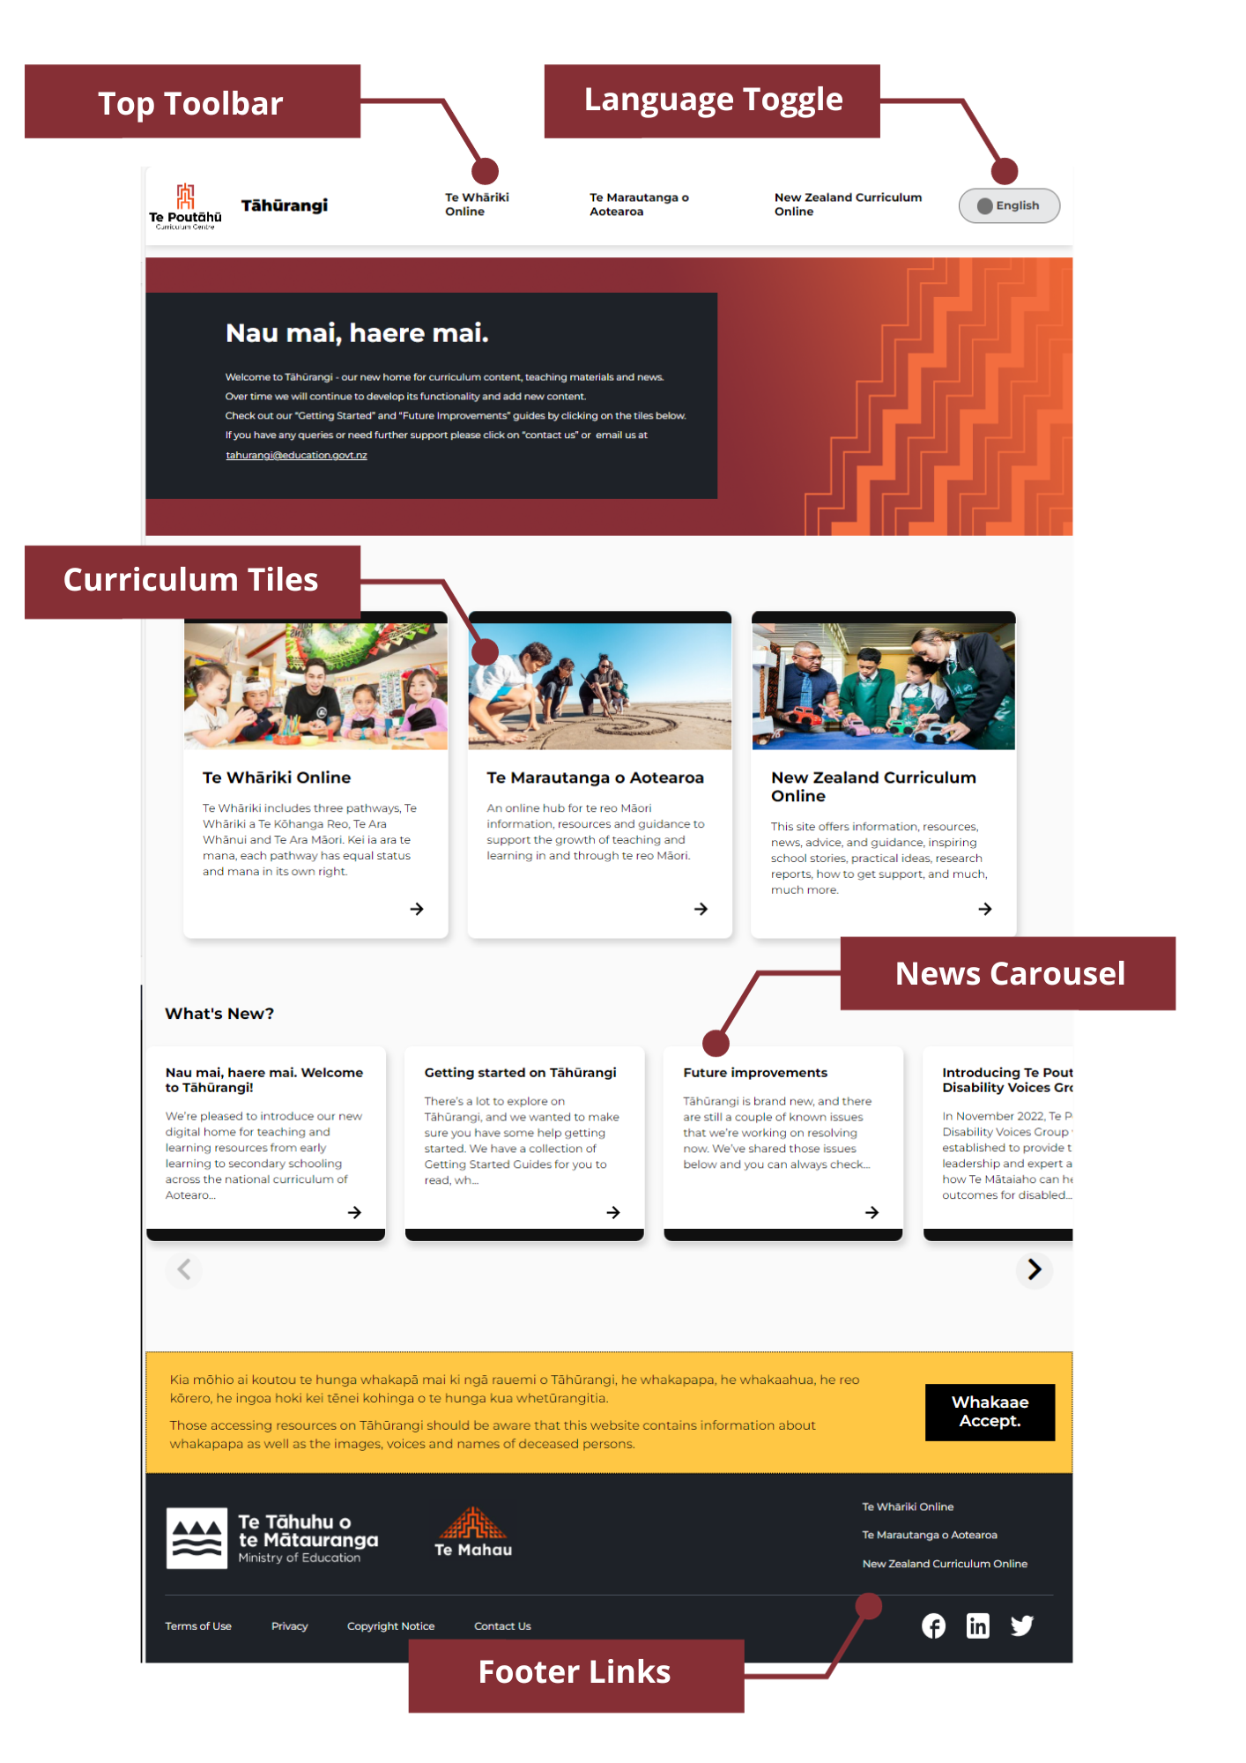

# *New Zealand Curriculum Online* Homepage

Click on a curriculum tile or toolbar button to navigate to the homepage for that specific part of the national curriculum.

This isthe homepage of *New Zealand Curriculum Online.* From here,you can start exploring all the resources, information, and news related to The 2007 New Zealand Curriculum.

Each page on this part of Tāhūrangi has a blue “Support” button in the top right corner where each of the user guides for each curriculum area can be found.

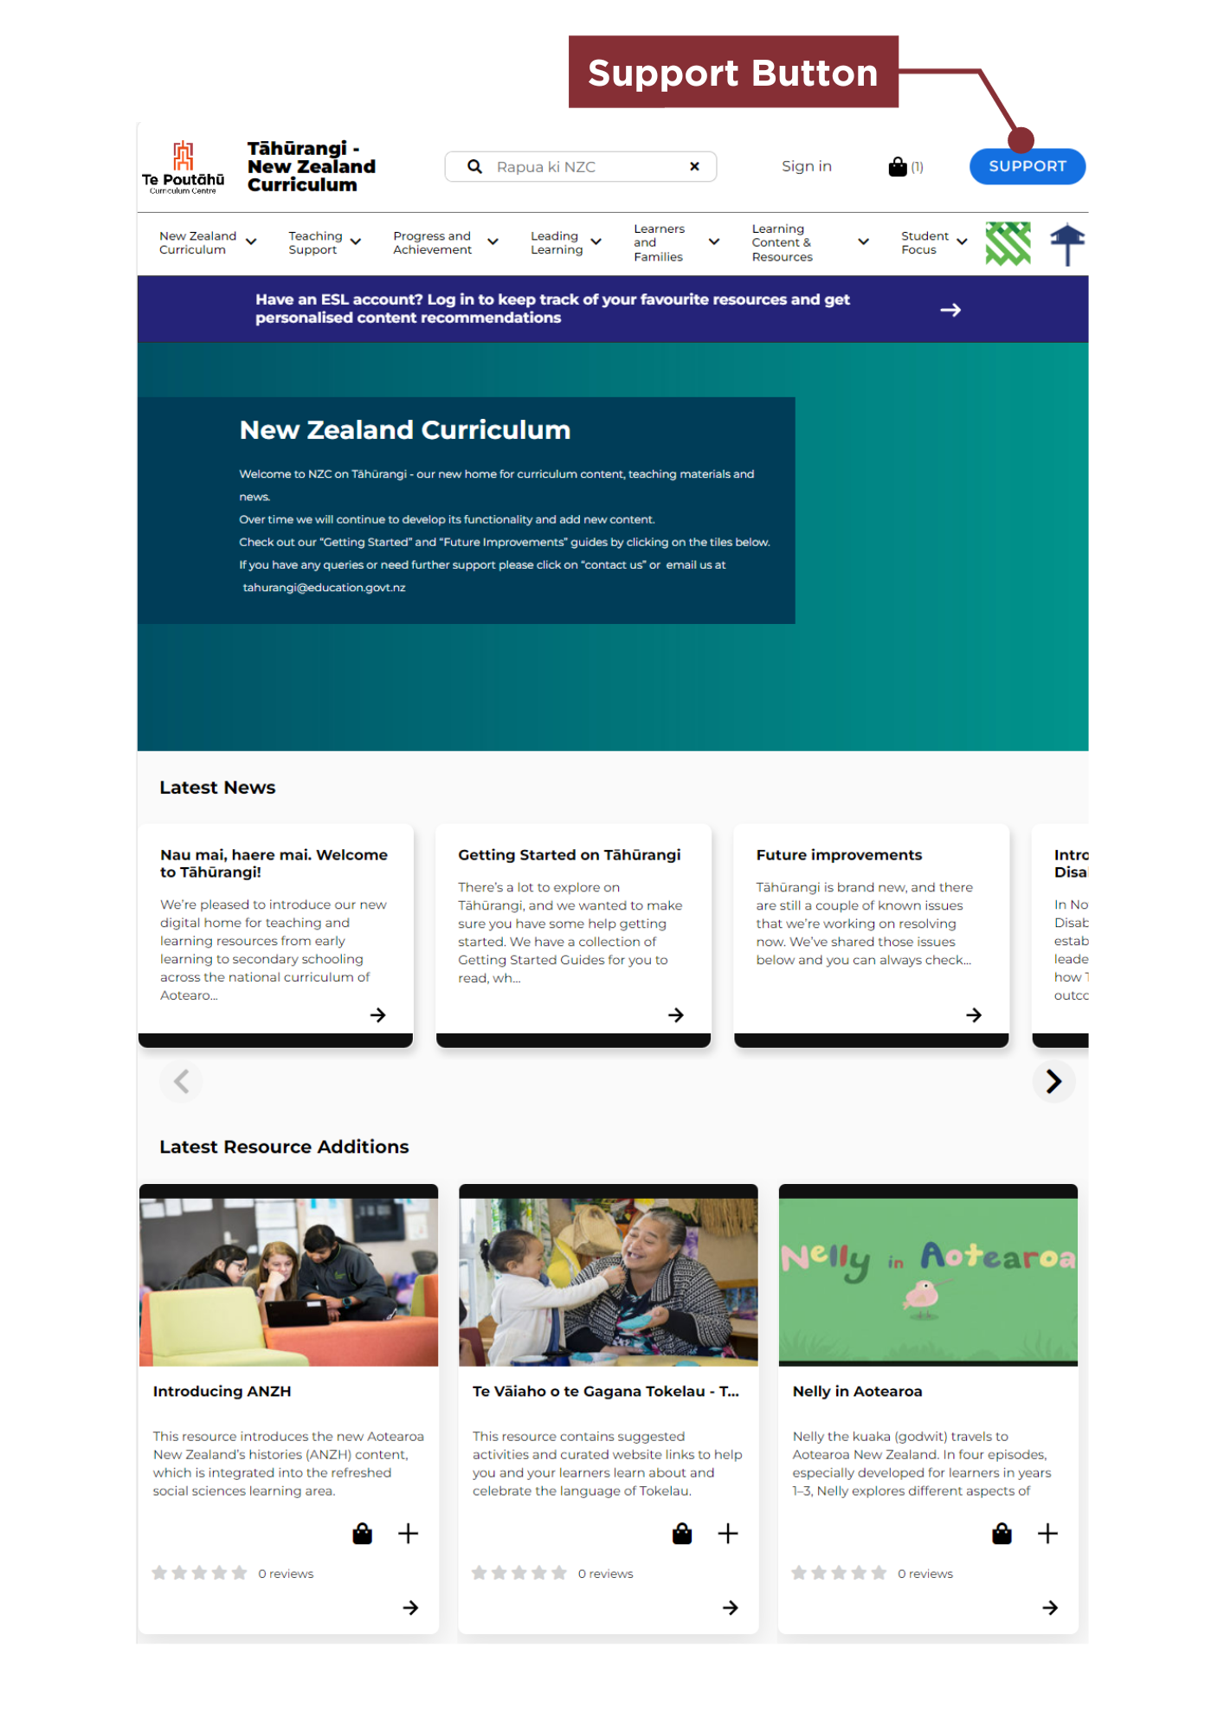

# Resource Search

Start your search for resources related to The 2007 New Zealand Curriculumby:

* using the search bar at the very top of the homepage
* using the navigation bar to explore the different areas (or landing pages) related to The 2007 New Zealand Curriculum
* using the second search bar in the body of any landing page.

Search bars are easily identifiable by their spyglass icon and te reo Māori words “rapua ki" (search for).

Refine search results by selecting one or more of the filters on the side of the search results page.

Tāhūrangi also enables users to search and access all the resources across the other curricula quickly and easily by selecting the Tāhūrangi tab on the search results page. Click the curriculum area to see all the available resources in each area. Search results automatically open in a new tab.

The search page also enables access to any artefacts (support materials) that match your search results or to access external sites, such as national libraries, by selecting those tabs.

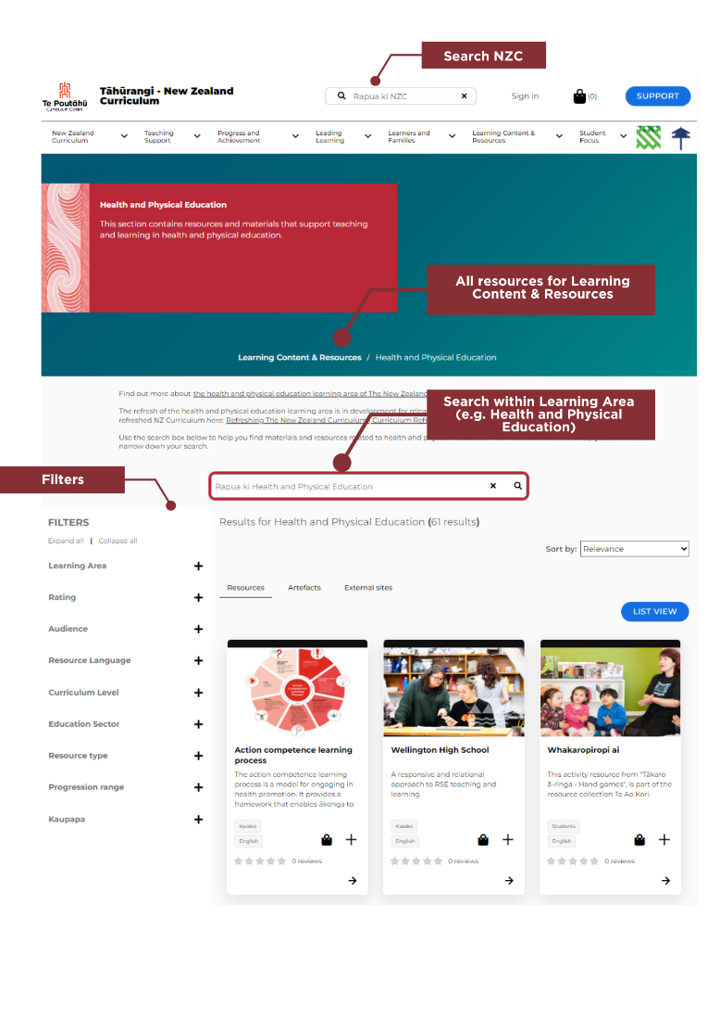

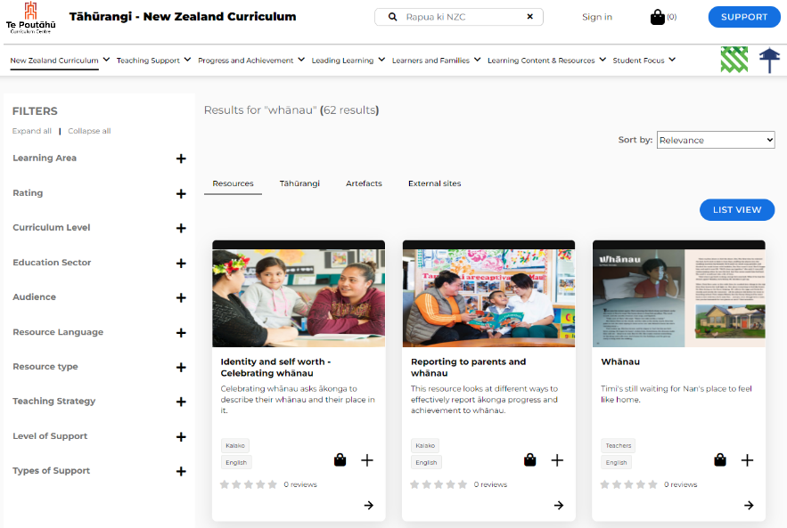

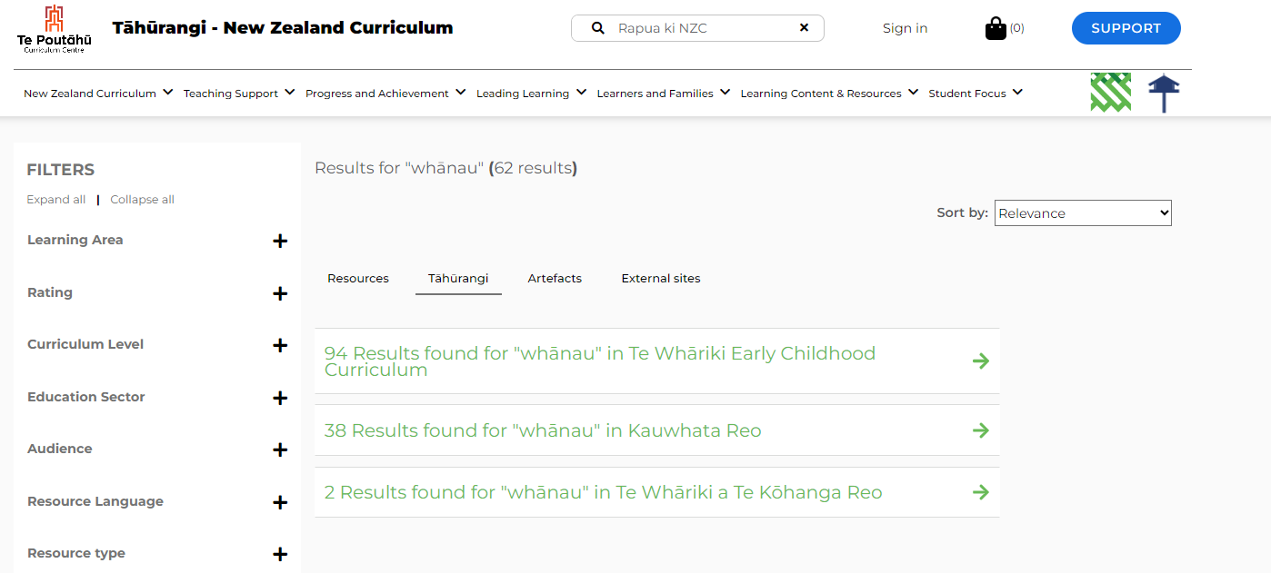

# Resource Tiles

Resource tiles appear when a search is performed and after navigating to a landing page using the navigation bar. These tiles provide the following information:

* **Image:** A thumbnail (small picture) that represents the resource.
* **Title:** The name of the resource.
* **Description:** A summary of what the resource contains.
* **Tags:** Two tags appear on the tile; the top tag indicates who the resource is intended for, and the bottom tag indicates the language the resource is in.
* **Kete:** The kete, represented by the basket icon, functions much like a shopping cart, allowing resources to be added directly to it. The resources in the kete can be viewed and downloaded at any time. Refer to the "Kete" section of this guide for more details.
* **Plus symbol:** Click on the plus symbol to add resources directly to one of your personalised collections, so that you can come back to it quickly at any time. This feature is currently only available to those with an Education Sector Logon (ESL). Refer to the “Collections” section of this guide for more details.
* **Arrow:** Click on the arrow to open the resource.

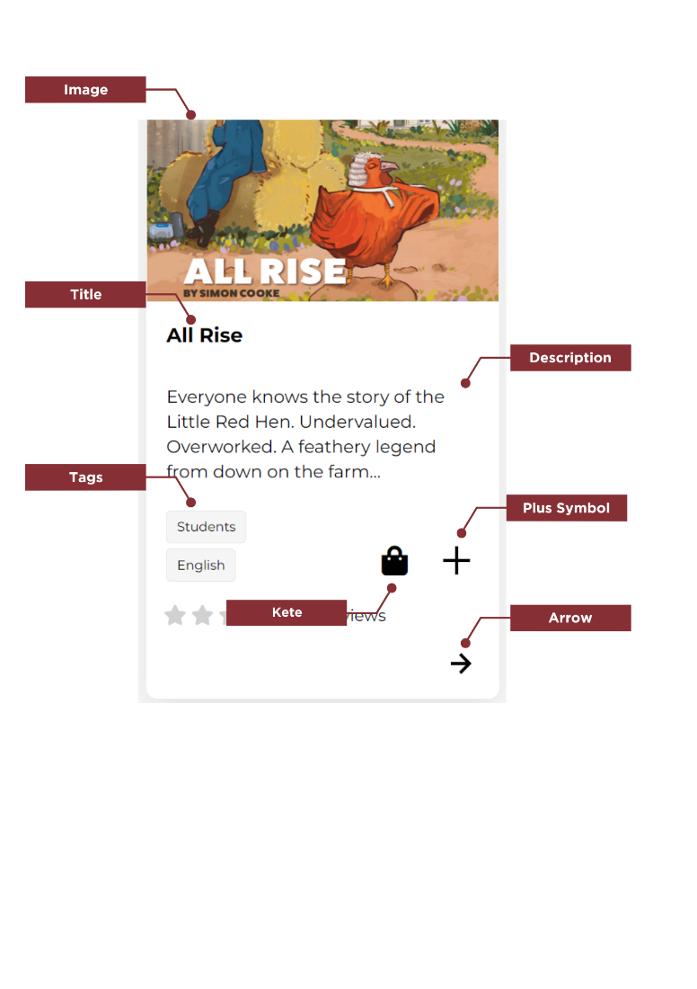

# Resource Features

The *New Zealand Curriculum Online* resources on Tāhūrangi have several different features.

The header section at the top of the page (pictured below) contains the following:

* **Kete**: Click here to view and download resources previously added to your kete. Refer to the “Kete” section of this guide for more details.
* **Support Button**: Click here to view information such as the whakapapa of Tāhūrangi, user guides, and contact details.
* **Navigation Bar:** Click here to find resources, either using the search feature or the navigation bar. The navigation bar has drop-downs. Resources for specific learning areas can be found under “Learning Content and Resources.”
* **Links** (to other curricula): Click on either of the two icons for *Te Whāriki Online* and *Te Marautanga* *o Aotearoa* to be directed to these two curriculum sites on Tāhūrangi.
* **Breadcrumbs**: Breadcrumbs indicate where the user is within the site according to the resource that is open, allowing them to easily navigate back to the broader area it sits within.

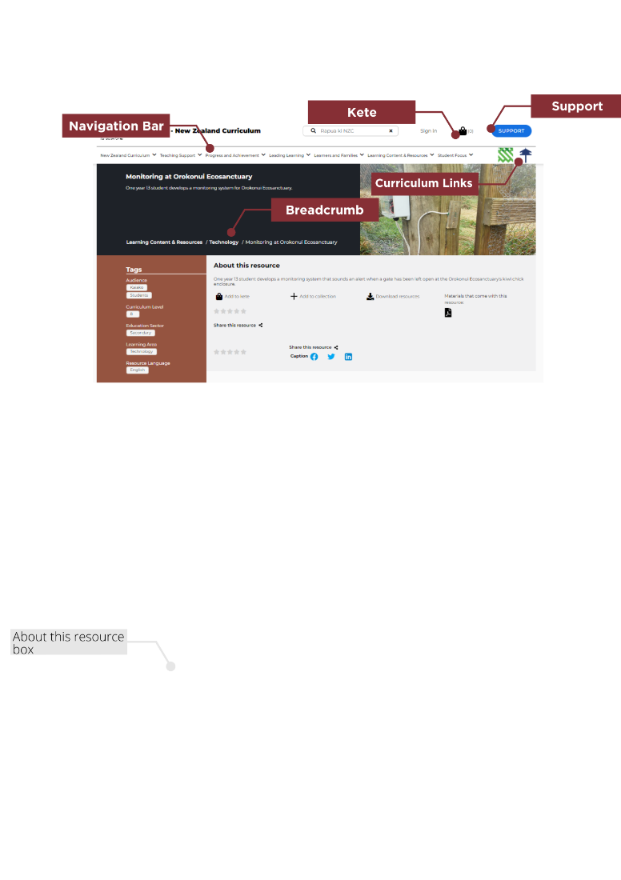

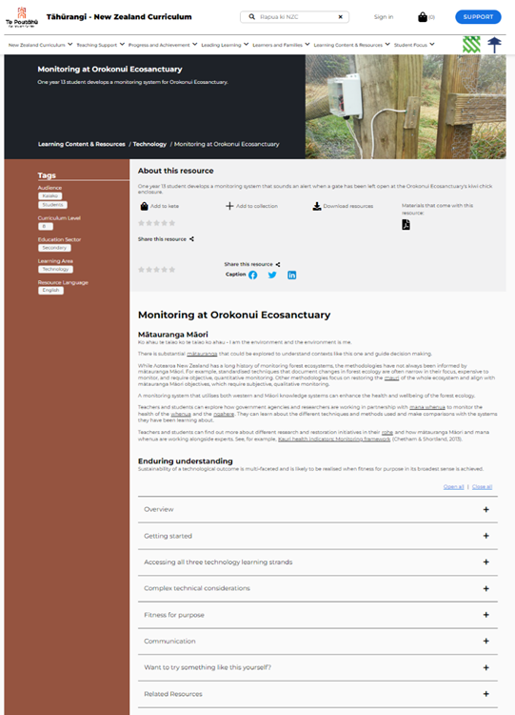

# Signing in

While resources, information, and many of the features and functions of Tāhūrangi are available to all users, educators with an Education Service Logon (ESL) will have access to a few extra features.

Use your ESL to:

* create a personal profile
* curate personalised resource collections
* share your collections with other ESL educators and gain access to other educators' collections
* subscribe to the Tāhūrangi communications channel
* view your download history (downloads from your kete).

There are two different areas on Tāhūrangi where you can sign in using your ESL:

1. The sign-in option on the header bar
2. Via the kete download page

**Option 1:** Via the header bar (in red below).

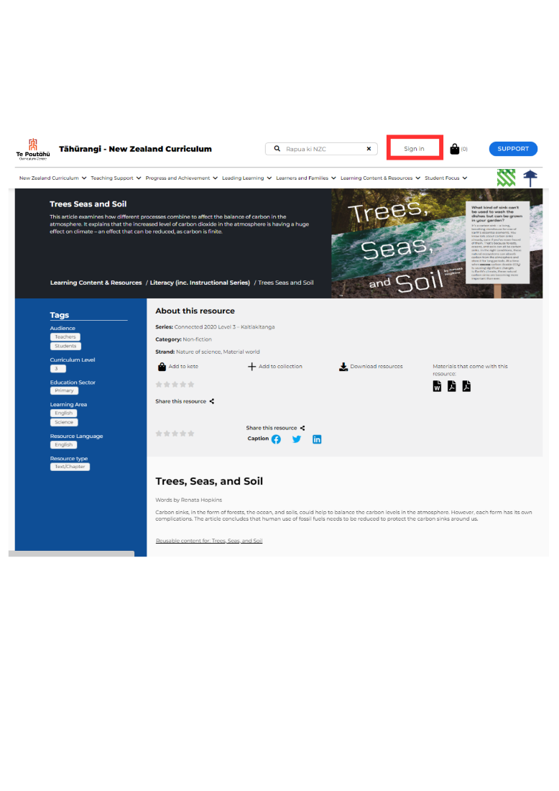

**Option 2:** Via the kete download page

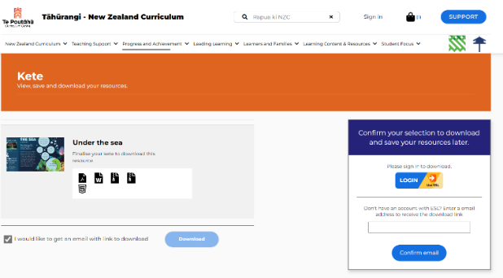

Once signed in, you will automatically be signed out after 20 minutes if your computer is inactive. Otherwise, you will be automatically signed out after 60 minutes to ensure your details are kept secure.

If you do not have an Education Service Logon (ESL), please send your enquiry to [service.desk@education.govt.nz](mailto:service.desk@education.govt.nz).

# Creating a Personal Profile

Once signed in, create a personal profile by selecting as few, or as many, descriptors about yourself and add your interests. Alternatively, choose tags from the search bar.

Once Tāhūrangi is fully functional, the system will remember your preferences to personalise your experience. For example, if you choose to receive communications from Tāhūrangi, the information you receive will reflect the preferences you selected when creating your profile.

Your personal information will be kept secure. To learn more about privacy and security, refer to our privacy statement in the page footer or email [tahurangi@education.govt.nz](mailto:tahurangi@education.govt.nz) for more information.

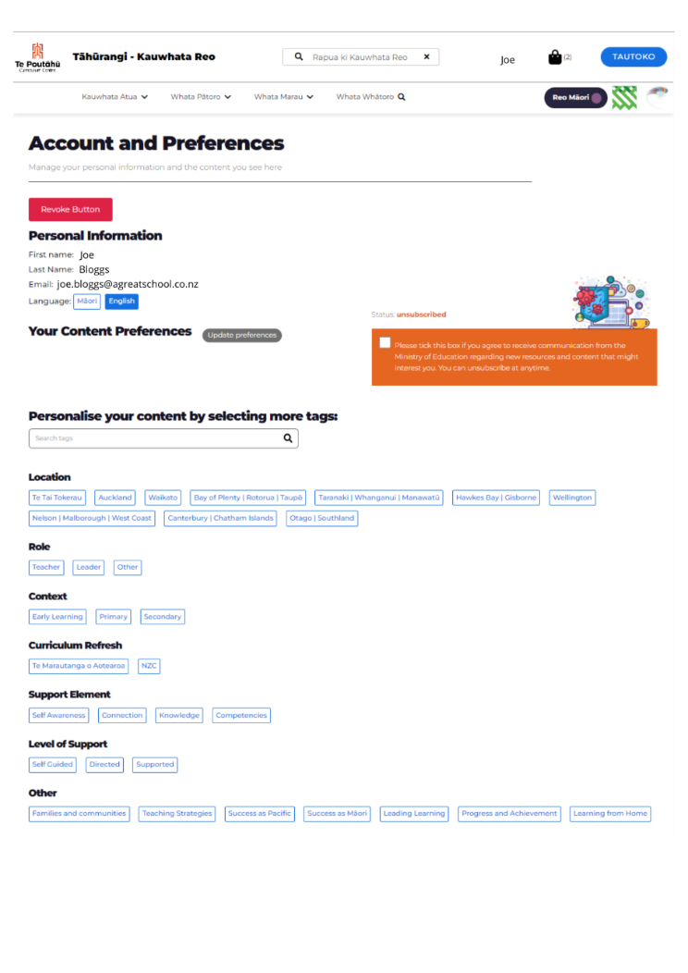

# Kete

The kete (the basket icon circled in red below) functions like a shopping cart, allowing items to be added. These can be reviewed and downloaded within the same browser session.

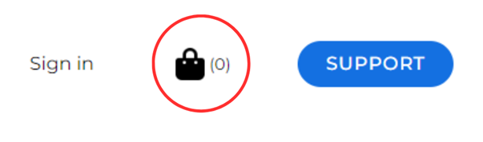

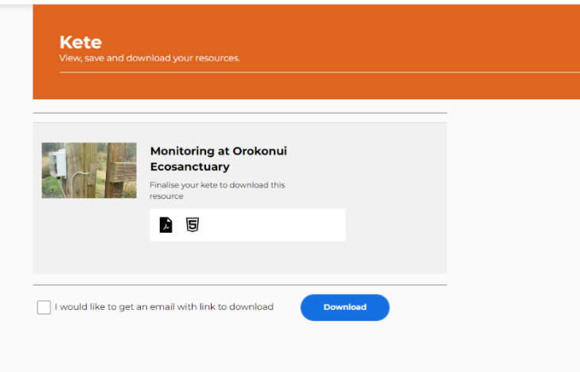

A pop-up menu will appear on the right-hand side of the screen. At the bottom of this menu, click “Finalise Kete.”

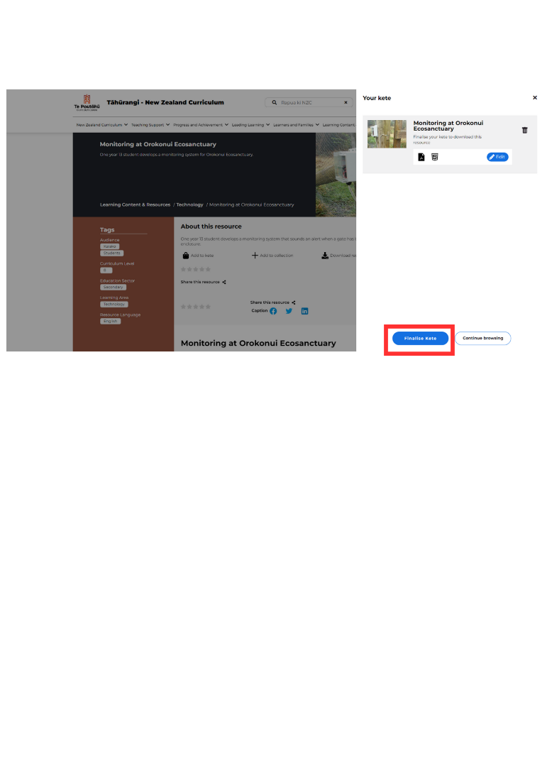

From here, you can either download resources to your device immediately by clicking either “Download” or the check box and entering your email address for a link to your kete to be sent to your inbox. This link will re-open your kete where you can download the resources. This link is valid for 72 hours.

Click on the kete icon to add support materials to your kete to download at any time. This is ideal when not connected to Wi-Fi.

Please note that while the site is still being developed, some resources may not be available at the time you add them to your kete. We are working hard to ensure all resources will be available soon.

# Creating a Collection

Currently, the collection function is only available to those with a registered ESL, which enables logged-in ESL users to save resources in curated collections.

This function, however, is still under development. Users can create resource collections across Tāhūrangi but are currently limited to viewing and downloading resources from within each curriculum area (not across the whole site).

Until this function is available, to view all your saved resources within the collection you have created in *Te Whāriki Online*, *Te Marautanga o Aotearoa*, or *New Zealand Curriculum Online*, you must return to that curriculum area via its homepage.

When a user is logged in using the “Sign in” button, or "Waitohu mai" when the page is toggled to show te reo Māori, the header will change to their preferred name according to their ESL profile. To find all saved collections, a user must sign into their profile and then click their name in the header.

# Sharing Collections

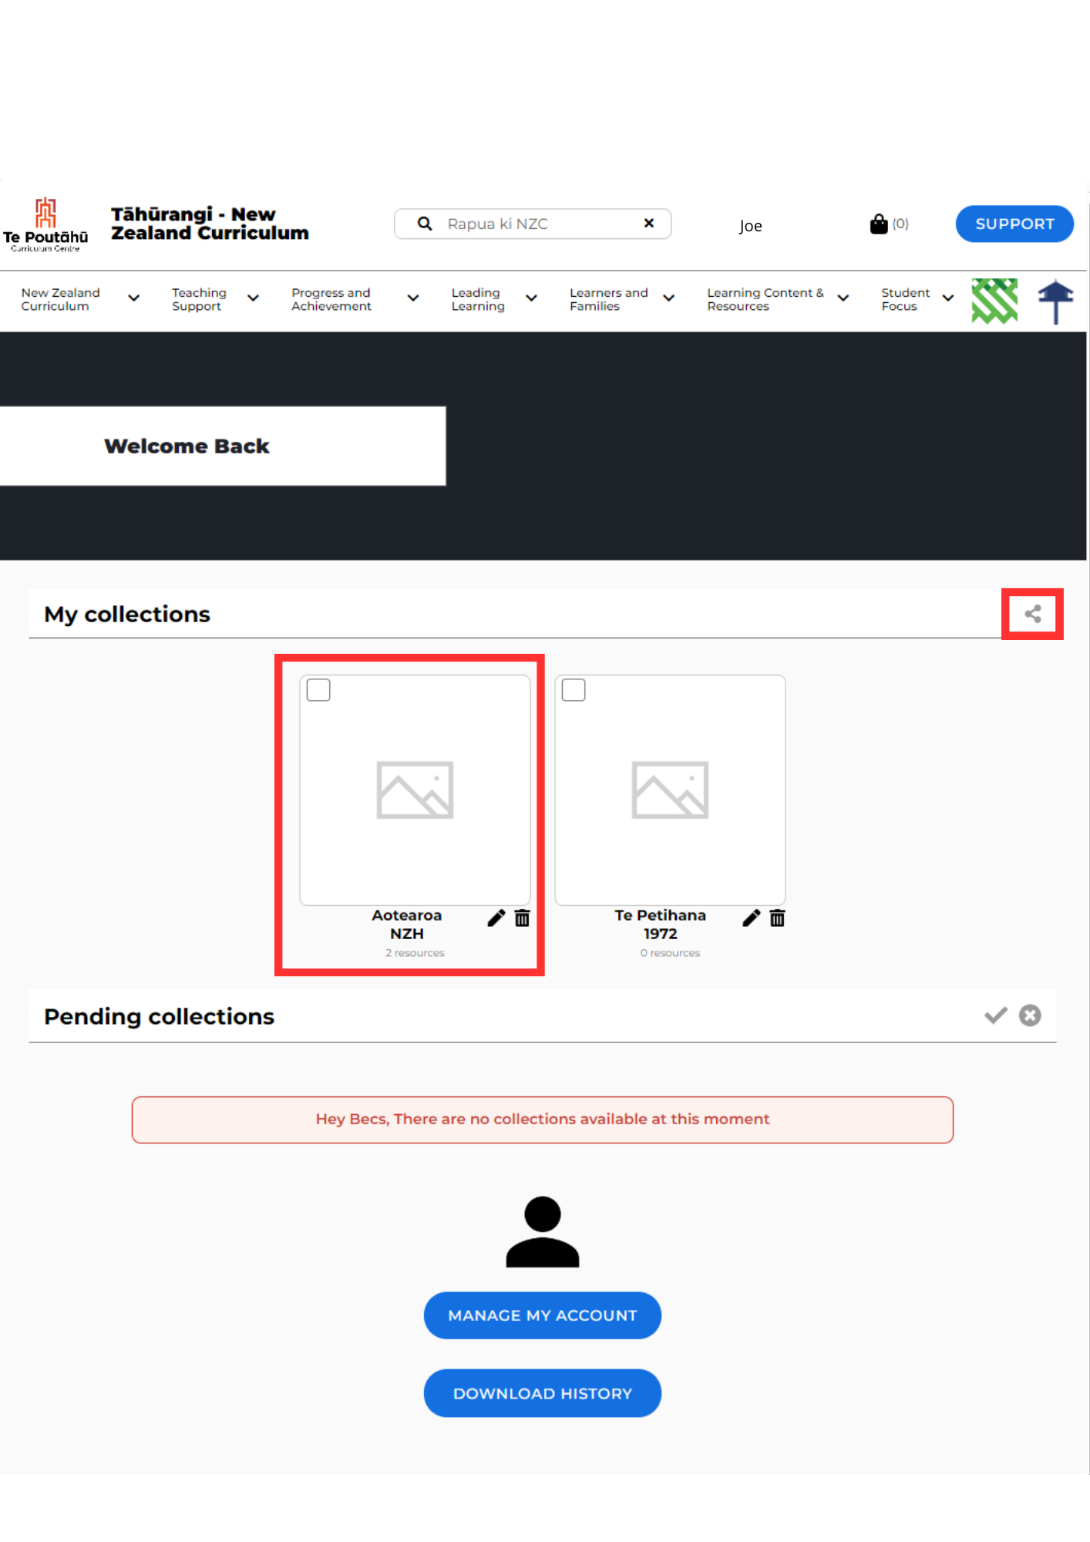To share your saved collections with others, click the check box at the top of a collection and then the "Share Collections" button. You will then be prompted to add the email address of the ESL-registered user you would like to share with.

# Glossary

* **Arrow:** Click on the arrow to open the resource.
* **Breadcrumbs:** Breadcrumbs indicate where the user is within the site according to the resource that is open, allowing them to easily navigate back to the broader area it sits within.
* **Collections:** The collections feature on Tāhūrangi is currently only available to those with a registered Education Sector Logon (ESL). When a user is signed in to their ESL profile on Tāhūrangi, they can create a collection and add any number of resources to it. Resources can be added to the collection from any curriculum. *Please note that resources within a collection can only be accessed via the collection when a user is in the curriculum site the resource belongs to.*
* **Description:** A summary of what the resource contains.
* **ESL:** The acronym for Education Sector Logon.
* **Image:** A thumbnail (small picture) that represents the resource.
* **Kete:** The kete (te reo Māori term for a woven basket) icon functions much like a shopping cart, allowing resources to be added directly to it. The resources in the kete can be viewed and downloaded at any time. Refer to the "Kete" section of this guide for more details.
* **Links to other curricula areas:** Icons for each curriculum area are available on the top toolbar.
* **Navigation Bar:** Click here to find resources, either using the search feature or the navigation bar. The navigation bar has drop-downs. Resources for specific learning areas can be found under “Learning Content and Resources.”
* **Plus symbol:** Click on the plus symbol to add resources directly to one of your personalised collections, so that you can come back to it quickly at any time. This feature is currently only available to those with an Education Sector Logon (ESL). Refer to the “Collections” section of this guide for more details.
* **Rapua**: Te reo Māori term that means “to search”.
* **Search Bar:** The spyglass icon indicates the search bar, which can be used to search all resources across the whole site. Te reo Māori has been intentionally chosen for the text that appears here that reads “Rapua ki New Zealand Curriculum.”
* **Sign In:** Registered ESL users can click here to sign into their Tāhūrangi profile.
* **Support Button**: Click here to view information such as the whakapapa of Tāhūrangi, user guides, and contact details.
* **Tags:** Two tags appear on resource tiles; the top tag indicates who the resource is intended for, and the bottom tag indicates the language the resource is in.
* **Title:** The name of the resource.